Convection Principles
When the wind blows and moves air across a structure, it can drive through all the cracks and openings in the building shell, pushing out the air we paid to heat or cool. Air infiltration and exfiltration is driven by pressure differences: Wind blowing against one side of a building (the windward side) creates a positive pressure against the building. But as it passes up and over the top and around the sides of the building, it creates negative pressures on the back side (the leeward side) of the building. All of the wind-driven air that leaks inside the building must be conditioned (heated or cooled), and when air leaks out again, pulled by negative pressures, it siphons away that conditioned air, further increasing the energy load on a building.

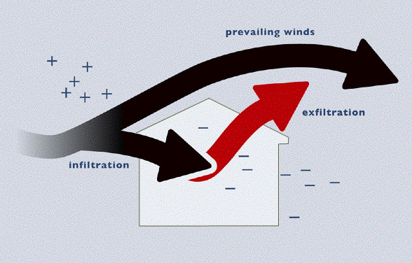
Air infiltration and exfiltration are forms of convection — the transfer of heat caused by physically moving molecules from one place to another. Convection is the flow of heat within a fluid, which is driven by temperature gradients. In air, which is a gaseous fluid, convection is often called the "stack effect." As air warms, the molecules move farther apart and the air becomes more buoyant, floating upwards. As it rises, cold air is pulled from below to replace it. The stack effect is easily observed as warm air flows up a chimney. When warm air rises inside a building, the entire building starts to function like a chimney. The rising air creates a positive pressure that drives warm air through cracks and openings high in the building. This, in turn, creates a negative pressure that pulls cooler air through the cracks and openings lower in the building.

Factors Affecting Convection
Heat transfer by convection is subject to five variables:

1. ΔT: Difference in temperature
As with all methods of heat transfer, a difference in temperature from one area to the other is a necessary condition.

2. t: time
Length of time infiltration occurs.

3. V: Volume of air
The volume of air within a building can be measured by multiplying the length, width, and height of interior space. The volume of air in a building remains constant, although the air itself changes.

4. AC/hr: Air changes per hour
House leakage is typically measured in cubic feet per minute (cfm) of air moving from one area to another. This rate of air change varies from house to house. Natural air exchange rates (AER) in a building range from about .1 AC/hr to 4 AC/hr. Both ASHRAE (American Society of Heating, Refrigeration, and Air Conditioning Engineers) and the DOE (Department of Energy) prescribe that a building should maintain a minimal air exchange rate of .35AC/hr to keep indoor air fresh and healthy.

Although the air exchange rate is often estimated at a mean value of 1 AC/hr, this is not a very reliable basis since the rate can vary widely from building to building. A more exact way to measure the leakiness of a building is to perform a blower door test. A blower door is a powerful fan that fits into an exterior doorway. This device can create a pressure difference across the building’s envelope equivalent to .2 inch of water column, which is the pressure equivalent of a 20-mph wind. Once the house is pressurized, it's possible to determine how much air, in cubic feet per minute, is being sucked in through cracks and holes within the building’s envelope while the fan is on. A blower door test produces a mechanical, or forced, air exchange rate that can then be converted to a natural air exchange rate.

5. HC: Heat Capacity of Air
The HC of air is the amount of heat (in BTUs) needed to change the temperature of one cubic foot of air one degree Fahrenheit.

HC_{air} = 0.02 BTUs/ft³

Calculating Heat Loss due to Infiltration
All five of the variables above can be combined in an expression of heat transfer by infiltration:

Q = V x AC/hr x HC_{air} x ΔT x t

where:
Q = Amount of heat (BTUs)
V = Volume of air
AC/hr = Air changes per hour
HC_{air} = Heat Capacity of air = .02 BTU/ft³°F
ΔT = Temperature difference
t = Time

For example: How would we calculate how much heat is replaced by infiltration over the course of one day in a 10,000-cubic foot building when it is 35°F outside and 68°F inside?

First, we'd need to run a blower door to determine the air exchange rate (AER). For this example, we'll say the Air Exchange Rate is found to be 1.5AC/hr.
Next, we'd calculate the temperature difference: 68°F - 35°F = 33°F
And we already know that HC_{air} = 0.02 BTUs/ ft³°F

Q = 10,000 ft³ x 1.5 AC/hr x 0.02 BTU/ft³°F x 33°F x 24 hrs
Q = 237,600 BTUs = total heat loss over one day.

To calculate the HVAC output required to make up for this amount of infiltration, we would divide by 24 to find the BTU/hr rating of the furnace.

Q = 237,600 BTUs ÷ 24 hrs = 9,900 BTU/hr.
That means the building would need a furnace that could provide 9,900 BTU/hr more output just to make up for the heat lost due to air infiltration.

The Impact of Air Infiltration
It’s estimated that Americans spend between $13 and $15 billion dollars per year on air infiltration losses in buildings. All of this is essentially heat loss by convection.

A typical building has over 2,000 linear feet of cracks and gaps. About 30% of these gaps are located along wall plate lines, both along exterior walls and through interior wall plates into the attic. Other bypasses include crawlspace leaks, window and door leaks, leaks around other wall penetrations (such as dryer vents and electrical cables), duct leaks that create enormous pressure imbalances across the building envelope, and leaks around exhaust fans for kitchens and baths.

Affects of Infiltration on Building Energy Usage
An effective air barrier installed on the exterior of a building does two basic things: First, it helps reduce the air exchange rate of the building. Because the air does not have to be reheated or re-cooled as many times per hour, the air barrier directly improves the energy efficiency of the building. Second, in many buildings, an air barrier can also increase the performance of the wall by eliminating windwashing.

Windwashing. Fiberglass insulation, one of the most common and inexpensive wall insulations, works by trapping air between glass fibers. Fiberglass works well as long as it is installed continuously, the batts are not compressed, and no air is allowed to blow through it. If any air moves through the insulation, the air scavenges away heat, an effect known as windwashing. Even if a wall is sealed on the inside using a poly vapor retarder, tape, sealant around windows, and gaskets at plate lines, wind may still infiltrate the exterior wall and draw heat away from the insulation, effectively lowering its R-value.

So, while insulation may do a great job of stopping heat transfer by conduction, it can do very little to stop heat loss by convection if there is no effective air barrier in place.

