HVAC: THERMOSIPHON SOLAR WATER HEATERS

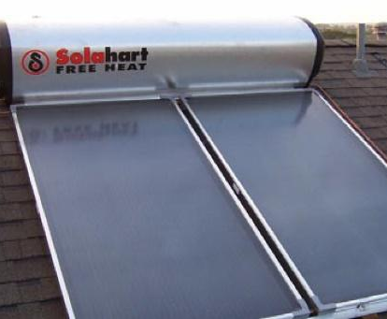 | WHAT?  Thermosiphon solar water heating systems are passive systems that rely on passive natural convection to heat water. Water is heated in a solar collector, usually on the roof; as it heats up, it rises, exiting the collector and moving into the storage tank. These simple systems are appropriate for warmer coastal climates.  ENERGY STAR-certified heating and cooling equipment, when properly installed, can yield annual energy bill savings of 10-30%.
WHY?
Every home includes some type of water heating system; these systems are usually powered by electricity or natural gas. Water heating accounts for about 20% of a home’s energy use. Thermosiphon systems, which are appropriate for warmer climates, utilize free energy from the sun to heat water, reducing energy usage and utility bills.
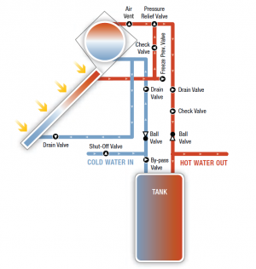 | HOW?  Solar thermal systems should be sized to provide at least 50% of a home’s water heating energy needs. Ideally, the solar thermal collector should be mounted on an unshaded, south-facing roof. It’s critical to ensure the roof mounting system avoids water intrusion and damage to the roof structure. Systems should be certified and installed according to local plumbing and building codes.

