Pressure Imbalances

Any equipment that blows or exhausts air can create pressure differences across the building envelope that pull or push air through the gaps in the building enclosure. While any unbalanced system will create some pressure difference, duct systems that leak significant amounts of air create the greatest pressure differences.

Residential Buildings

Supply leaks. Although it is desirable for home to have HVAC systems and ducts installed in conditioned space, most homes have HVAC systems installed in unconditioned or semi-conditioned space. Typically, a home will have more supply ducts than return air ducts, and that means there will likely be more supply duct leaks. If those supply ducts are located outside the building envelope (in the basement/crawlspace, attic, or garage), their leaks will create a positive pressure outside the envelope where the blower runs and a negative pressure inside the home.

In most homes, the supply ducts are routed outside the building enclosure in attics and crawlspaces. But if those ducts leak outside the envelope, the return side of the system inside the house will be starved for air. As the return pulls its air, the missing supply air must be made up by air pulled in through the cracks and gaps in the building enclosure from outside the building. Not only does that raise the heating or cooling bill, but the negative pressure can also cause a fireplace or combustion appliance to backdraft, which introduces carbon monoxide to the indoor environment.
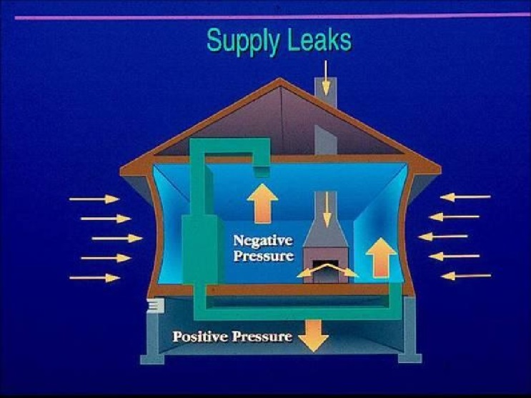
A negative pressure inside the home can pull in an enormous amount of water vapor, particularly in a hot, humid climate where the incoming air is laden with moisture. If that moisture hits a cool polyethylene vapor barrier on the interior of the air conditioned home, the moisture will condense in the wall and create problems.

Return leaks. Duct leaks on the return side of an HVAC system can cause just the opposite problem by putting the building under a positive pressure. This creates the worst problems in a home with a lot of indoor humidity. Positive pressure indoors can force humid air into building cavities where it is likely to condense on building surfaces and create moisture problems.
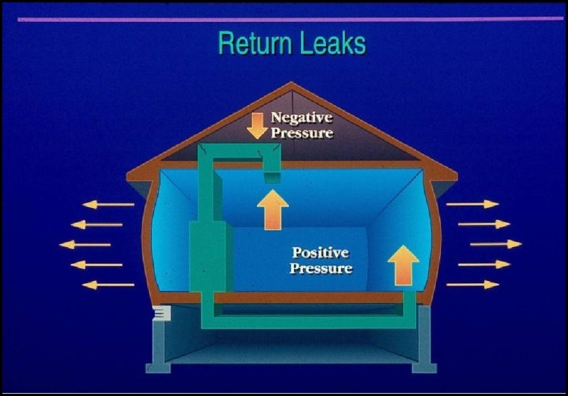

Leaks in the return plenum result in an imbalance

— excess air will be delivered on the supply side and create a positive pressure that can force humid indoor air into wall cavities, leading to hidden moisture problems.

Closed Doors Another common problem arises when pressure imbalances are created by separating supply and return ducts within a home with interior doors. For example, if a supply duct is located in a bedroom and the door is shut, then the bedroom will be under positive pressure and the other living areas will be under negative pressure.

It’s not uncommon for one part of a structure to be under positive pressure and another part to be under a negative pressure, depending on doors being opened or closed. Each of these pressure imbalances creates pathways for moisture-laden air to infiltrate and exfiltrate. The solution is to install “jump ducts” (also known as transfer grills, or comfort vents) that transfer air from one room to another and allow the house pressure to equalize.

