HVAC: SUPPORT FOR FLEXIBLE DUCTS

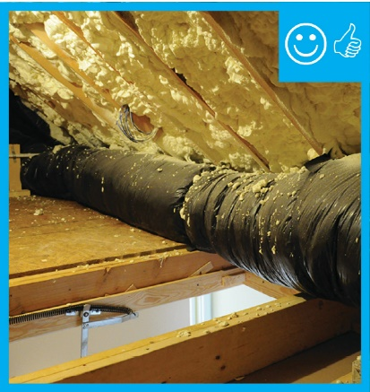 | WHAT?  When ducts are installed in a vented, uninsulated attic or crawl space, they should be supported with straps or saddles or other approved system. The support should be installed at regular intervals so that the ducts do not sag and so they are not pinched or compressed.
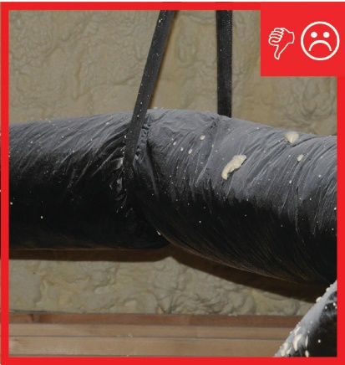 | WHY?  Flexible duct, known as flex duct, is a convenient material for attaching supply air outlets to rigid trunk ductwork. In many cases, flex duct comprises the entire duct system. Ducts must be properly installed and supported to avoid air flow losses, energy losses, and moisture problems.
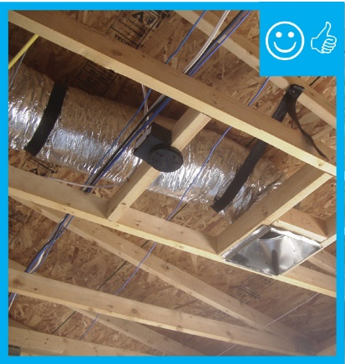 | HOW?  Ducting may be supported by straps, saddles, factory-installed suspension systems, or saddle-shaped supports held up by poles that are attached to attic framing. Ducts should be supported at the manufacturer’s recommended intervals, but in general, the supports should be at least 1.5 inches wide and installed no more than 4 feet apart. There should be no more than ½ inch sag per foot between the supports. Flexible ducts may rest on ceiling joists or truss supports, but they must still be supported.

