HVAC: SEALED AND INSULATED METAL DUCTS

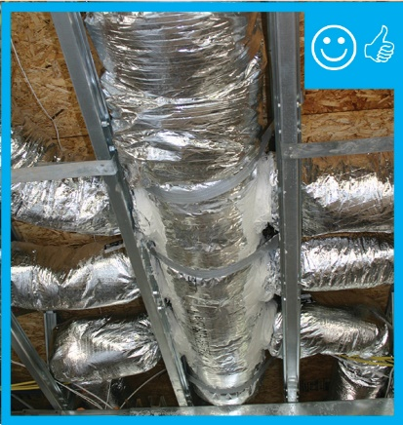 | WHAT?  When metal ducts are located in an unconditioned space, thermal insulation with a vapor barrier can help prevent heat gain or loss through the duct walls. This also keeps condensation from forming on the ducts.
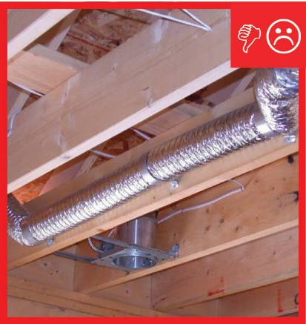 | WHY?  Ideally, ducts should be located in conditioned space, such as within a dropped ceiling, between floors, in an insulated basement or crawlspace, or in an unvented attic. However, sometimes ducts are located in an unconditioned space, such as a vented attic or vented crawlspace. In these cases, they should be sealed and insulated to prevent heat loss due to air leaks and conduction and to provide some protection against harsh conditions.
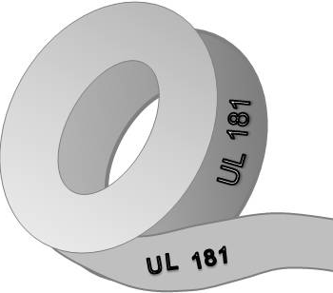 | HOW?  For duct insulation to perform properly, it must be fully aligned and in contact with the walls of the duct system. Metal ducts for residential HVAC systems are typically insulated on the exterior using a "duct wrap"—for example, fiberglass blanket insulation with a foil-faced vapor barrier. Ducts should also be sealed with duct mastic or metal tape that meets the requirements of UL-181, UL-181A, or 181B.

