HVAC: ROOMS WITH FUEL BURNING APPLIANCES

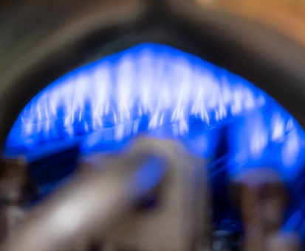 | WHAT?  Open combustion, aka “natural draft” fuel-burning appliances work by burning fuel such as natural gas or propane. These appliances pull combustion air from the room surrounding it. Rooms containing these appliances must be isolated from the rest of the home to protect occupants from harmful gases.
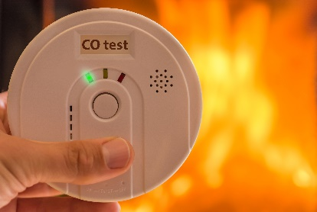 | WHY?  There is a greater risk of back-drafting when natural-draft gas appliances are installed in airtight homes. Backdrafting can draw carbon monoxide into the building, putting occupants at risk. For this reason, a new section in the 2015 IECC/IRC requires fuel burning appliances to be isolated from the building’s thermal envelope.
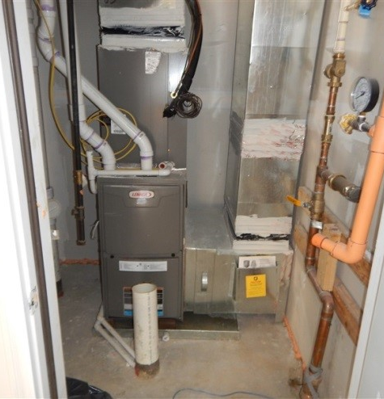 | HOW?  The new code allows two options for fulfilling the requirement. The gas appliance may be located in a room outside of the home’s thermal envelope. This room could be in an unheated garage, an unheated basement or crawlspace, or an unheated attic. Alternatively, the gas appliance can be located in a room that’s isolated from inside the thermal envelope. In other words, the room may be inside the main house, but it must be insulated and sealed off from the rest of the conditioned space.

