HVAC: QUALITY INSTALLATION

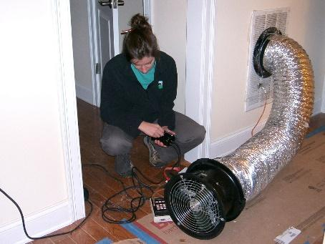 | WHAT?  Quality installation—that is, installation by certified professionals who follow industry standards and manufacturers’ recommendations—will save energy, improve equipment performance and safety, and ensure the system’s longevity.  Professional HVAC installers follow recognized industry standards like those set by the Air Conditioning Contractors of America (ACCA) for proper design, sizing, installation, charging, and commissioning of HVAC equipment.
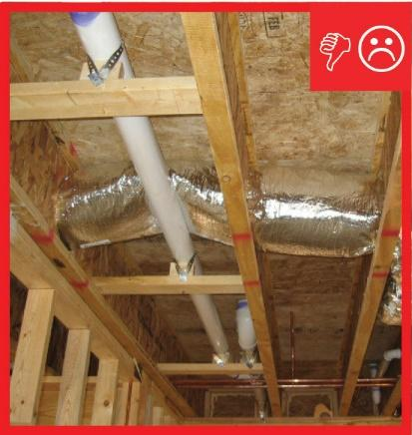 | WHY?  More than half of all HVAC systems in US homes are believed to perform poorly due to one or more installation issues, which includes oversizing of furnaces and air conditioners and improperly designed, sized, and installed duct systems. Such systems will not operate as efficiently as they should; they also may not last as long as they could.
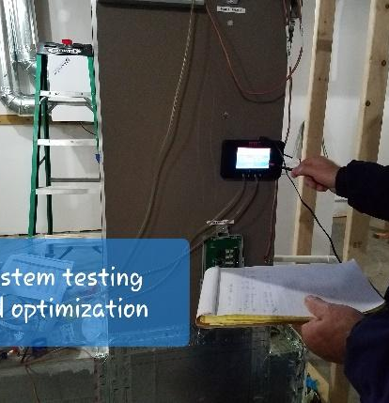 | HOW?  The components of quality installation include proper sizing of equipment and component matching; ensuring the correct amount of refrigerant, or correct refrigerant charge; ensuring adequate airflow to match refrigerant capacity; and properly sealing ducts to minimize leaks. Savings from improved installations may range from 18% to 36% for air conditioners and heat pumps and 11% to 18% for furnaces.

