HVAC: PROPER VENTILATION FOR FIREPLACES AND STOVES

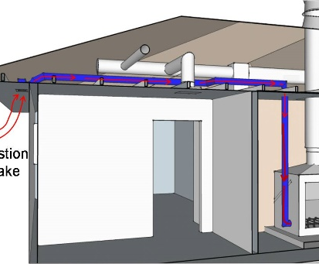 | WHAT?  If fireplaces are installed, ensure that ventilation air is provided directly to the fireplace and conduct combustion safety testing to ensure the fireplace will not be backdrafted by other exhaust fans in the home.
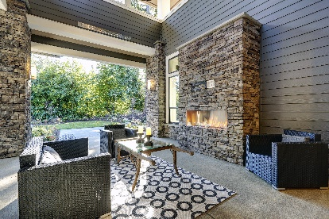 | WHY?  A fireplace needs adequate combustion air to function properly and safely. Natural-draft and mechanically drafted appliances take all or some of their combustion air from the indoor space, while direct-vent sealed-combustion takes 100% of its combustion air directly from outdoors. Natural-draft fireplaces are vulnerable to being backdrafted when the chimney is cool or the fire is burning low.
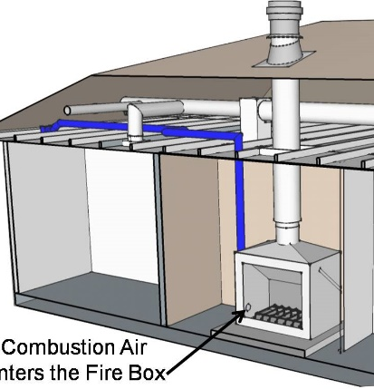 | HOW?  If installing a natural-draft fireplace, install a dedicated combustion air duct that brings outside air directly into the firebox. The fireplace should have tight-fitting glass doors across the face of the fireplace opening. To ensure backdrafting does not occur, the rater will verify that the total net rated exhaust flow of the two largest exhaust fans is ≤ 15 CFM per 100 ft2 of occupiable space. And of course, all installed fireplaces, woodstoves, pellet stoves, and masonry heaters should meet applicable code requirements.

