HVAC: PROPER SIZING OF HVAC SYSTEMS

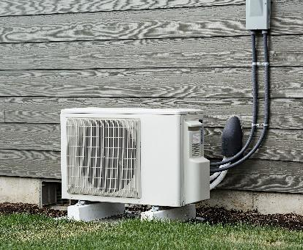 | WHAT?  To right-size an HVAC system, you must first accurately determine both the heating and cooling loads. These loads are then used with sizing calculations based on recognized industry standards, such as those developed by the Air Conditioning Contractors of America, or ACAA.
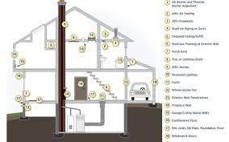 | WHY?  “Rules of thumb” are too often used to size comfort systems, which results in excessively oversized systems. This leads to increased cost, wasted energy, and too-frequent on-and-off cycling, which can compromise comfort and efficiency.
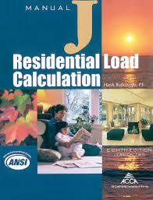 | HOW?  ACCA’s Manual J, Eighth Edition, enables contractors to perform load calculations for homes. Equipment, including ducts, should be selected based on these loads, and the blower capacity must meet the volume of air (cfm) range needed. Note that in the US, the cooling load is often larger than the heating load. Also, the loads in energy-efficient homes are often so small that they fall outside manufacturers’ range of capacities.

