HVAC: PROPER INSTALLATION OF FILTERS

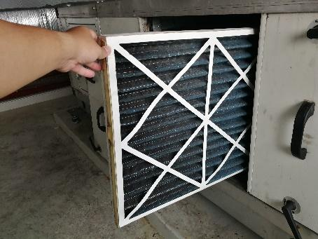 | WHAT?  Filters are an important component of ducted heating and cooling systems. When installed on the return side of the HVAC air handler, filters protect the HVAC motor and improve indoor air quality. They are installed in fresh air intakes to clean outside air that is brought into the home.
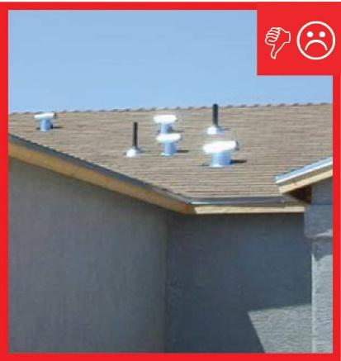 | WHY?  Filters with higher MERV (Minimum Efficiency Reporting Value) ratings (MERV 6 and above) can trap pollutants like pollen, dust mites, and mold spores. However, a dirty or clogged filter can dramatically reduce air flow, increasing furnace run time, wear on the motor and energy consumption. Filters should be replaced or cleaned frequently and located in a place that is easily accessible for the homeowner.
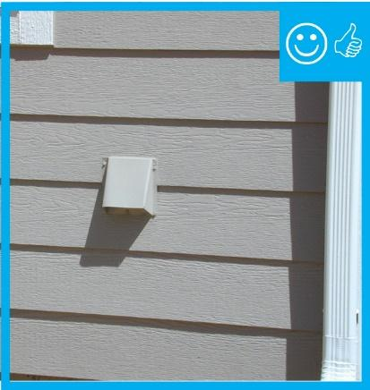 | HOW?  If the furnace air handler is in an accessible location such as a utility room, it can be installed in the air handler at the return plenum. If the furnace is in the attic, the attic should be equipped with a staircase or pulldown stairs and a permanently installed walkway. The air handler box should be equipped with a filter media box with a gasketed removable access panel cover.  If the furnace air handler is located in an inaccessible location such as a crawlspace or attic without a staircase, a furnace filter should be located in each return grille.  If a fresh air intake is ducted to the air handler, a filter should be installed at the intake in an easily accessible location.

