HVAC: PROGRAMMABLE THERMOSTATS

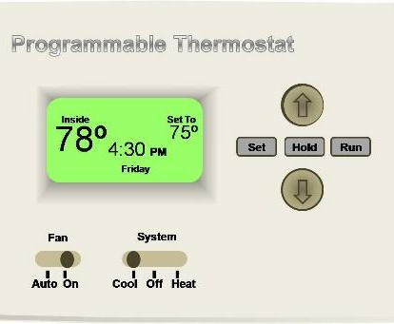 | WHAT?  Programmable thermostats are used to control heating and cooling equipment. They can be programmed so that they automatically adjust temperatures based on a set schedule. Smart thermostats can adjust based on occupancy or activity.  Occupants can save up to 10% per year on heating and cooling by turning the thermostat back 7°-10°F for 8 hours a day.
WHY?
Energy is wasted when HVAC systems heat or cool homes to the same temperatures all the time. Programmable thermostats save money and energy by automatically adjusting the temperature at certain times of the day, such as when occupants are at work. So-called “smart” thermostats have even more sophisticated capabilities. If every home used a smart thermostat, we would save 56 trillion BTUs of energy per year.
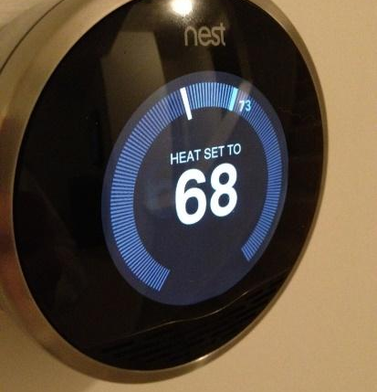 | HOW?  Programmable thermostats adjust temperatures according to a set schedule. Electronic thermostats with adaptive recovery technology “learn” from experience how to most efficiently change from one temperature to another. Smart thermostats offer even more control. They can be programmed to automatically adjust temperatures when occupants are home, away, or asleep. Occupants can control them remotely through a smartphone, and they can track and manage energy use.

