HVAC: HIGH-EFFICIENCY BOILERS

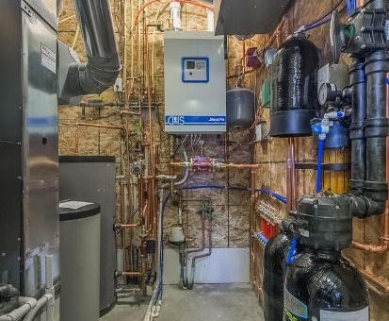 | WHAT?  High-efficiency boilers produce hot water that can be used to heat homes through several different distribution methods. The hot water can be sent through loops in the floor or through metal radiators mounted along the wall or near the floor; it can also be directed from a water heater to a coil in an air handler equipped with a fan, which blows air through supply air ducts to the home. Most combustion boilers are fueled by natural gas, but water may also be heated or preheated by a solar thermal water heating system or by a geothermal heat pump.
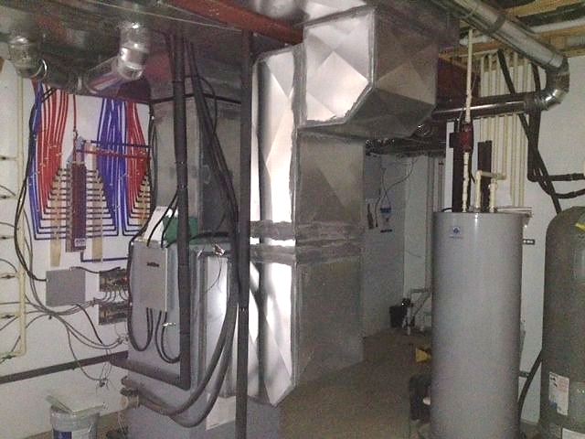 | WHY?  According to the U.S. Energy Information Administration (EIA), up to 11% of existing households use some form of hot water or steam heat. Choosing a high-performance boiler can significantly reduce heating costs. Often, the same appliance can also supply domestic water heating.
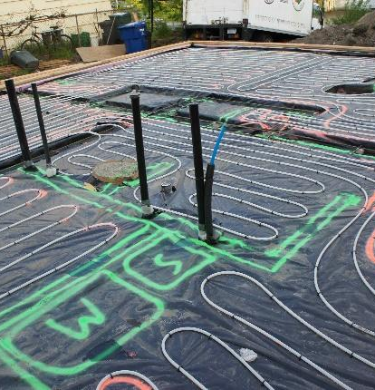 | HOW?  The highest-performing boiler should be selected to meet the design heating load of the project. High-performance boilers include sealed-combustion, direct-vent boilers, which can have Annual Fuel Utilization Efficiencies (AFUE) exceeding 94%. These are also the safest boilers to install inside a home because they release combustion byproducts directly to the outdoors. The boiler and distribution system should be sized to meet the calculated heating load for the home. Select a boiler with a modulating burner for increased efficiency.

