HVAC: HEAT PUMP WATER HEATERS

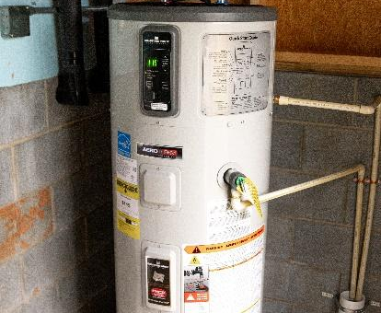 | WHAT?  Heat pump water heaters are an energy-efficient alternative to electric-resistance water heaters. They work by removing heat from the surrounding space into the hot water tank. Heat pump water heaters range in tank volume, first-hour capacity ratings, efficiency, and size.
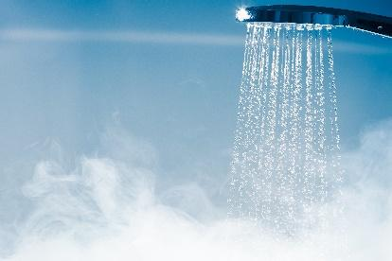 | WHY?  The water heater is responsible for about 17% of the total energy use in the average home. Heat pump water heaters can be two to three times more efficient than a conventional electric water heater, saving significant energy and cost.
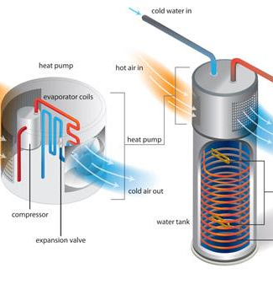 | HOW?  Heat pump water heaters use electricity to move heat from one place to another instead of generating heat directly. Most operate as “hybrid” devices: they utilize the heat pump whenever possible, but include a backup conventional resistance heating element for large loads. Note that since these appliances draw heat from the surrounding air, they have specific requirements for installation, including temperature range and closet size.

