HVAC: FIBER BOARD DUCTS

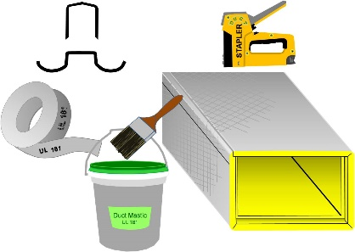 | WHAT?  Fiber board ducts are fabricated from flat sheets of fiberglass. Fiber board ducting can be used for heating and cooling ducts in HVAC systems; however, it is not recommended for ventilation ducts, especially in humid climates.
WHY?
As a duct material, fiber board has several advantages. It is inherently insulating, with an R-value of 4.3 per inch. The material is also airtight. Fiber board is relatively inexpensive and easy to work with; however, the overall performance (air tightness) of the system depends on proper fabrication and joining of the sections.
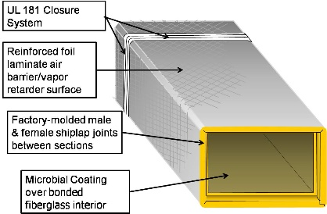 | HOW?  HVAC contractors typically purchase duct board sheets by the carton (and fabricate the ducts themselves in the shop or on site. Sections are assembled by matching factory or field-cut shiplapped male and female ends. The shiplapping ensures close-fitting, smooth joints when duct sections are joined together.

