HVAC: ENERGY RECOVERY VENTILATION

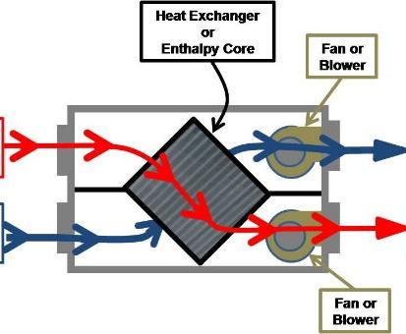 | WHAT?  Energy recovery ventilation systems provide a controlled way of ventilating a home while minimizing energy loss. They reduce the costs of heating ventilated air in the winter by transferring heat from the warm inside exhaust air to the colder outside supply air. In the summer, the inside air cools the warmer supply air to reduce cooling costs.
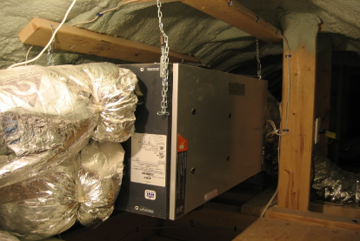 | WHY?  Many homes are missing whole-house fresh air systems that ensure adequate dilution of moisture, dust, pollen, and particulates inside the home. These contaminants can trigger asthma and allergy attacks as well as other health problems. Balanced heat recovery ventilation effectively dilute these contaminants, and save energy by recovering heat, as well.
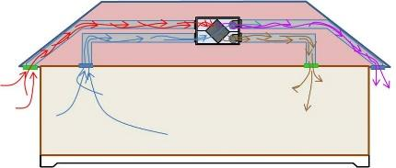 | HOW?  There are two types of energy-recovery systems: heat-recovery ventilators (HRV) and energy-recovery ventilators (ERV). Both include a heat exchanger, one or more fans to push air through the machine, and controls. In addition to exchanging heat, ERVs transfer a certain amount of water vapor; this helps the humidity inside the home stay more constant.

