HVAC: DUCTED RETURNS

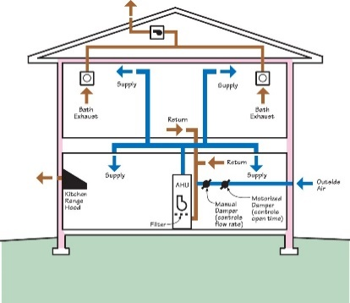 | WHAT?  Ducted returns provide a path for room air to return to the central air handler. Dedicated returns help ensure that the air pressure between rooms is balanced. They are critical for the performance of the HVAC system in an energy-efficient house.    
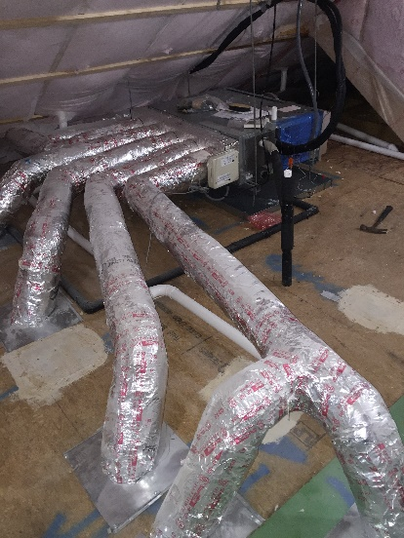 | WHY?  HVAC systems use fans to push heated and cooled air through ducts into living spaces. Air must be recirculated, or returned, to the central HVAC equipment, where it is once again heated or cooled and sent back to living spaces. Most homes use centrally located return ducts to capture and return air; however, this can cause comfort issues, including drafts and temperature differences between rooms.
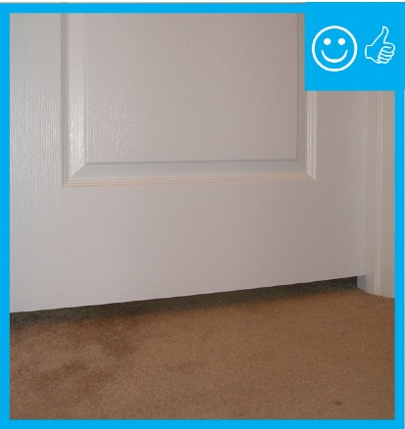 | HOW?  A comfort return system uses separate ducts in each major room to capture and deliver air back to the central furnace or air conditioner. Dedicated return ducts may also be used alongside other strategies, such as central return ducts, transfer grilles, jump ducts, and undercut doors. Just as with supply ducts, return ducts must be air sealed.

