HVAC: DUCT TERMINAL SIZING

WHAT?
Correctly sized supply and return air grilles promote optimum airflow throughout a home. These grilles should never be smaller than the diameter of the duct. Adjustable grilles at duct terminals allow air to be directed within a space.

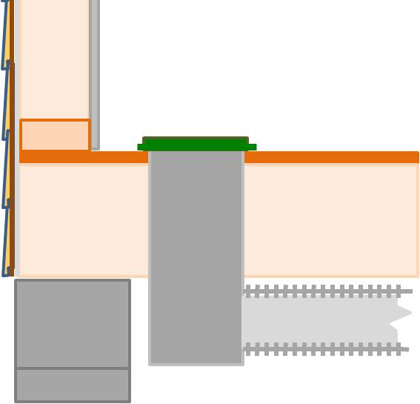 | WHY?  Just as sizing is important for ducts, so it is important with the registers at duct ends, or terminals. Even with high-quality HVAC systems, if the register grilles are incorrectly sized, of poor quality, or badly placed, homeowners can end up with drafts or stagnant air, noise problems, and other comfort issues.
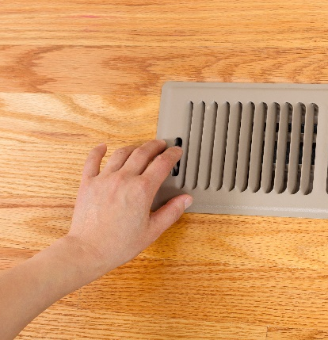 | HOW?  A trained HVAC contractor will select properly sized, high-quality, adjustable supply air diffusers, grilles, and registers and locate and adjust them in accordance with recognized industry standards. In general, adjustable grilles with louvers are best for supply duct terminals. These allows air to be directed upward or downward, depending on the season. The registers for return grilles are fixed.

