HVAC: DIRECT VENT EQUIPMENT

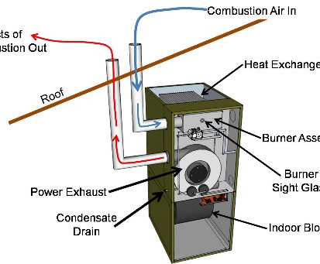 | WHAT?  Direct vent combustion appliances include furnaces, boilers, and water heaters that utilize natural gas or propane that are equipped with a pipe to bring combustion air directly from outside to the combustion chamber. They also have a second sealed vent pipe to carry exhaust gases directly to the outside from the appliance.
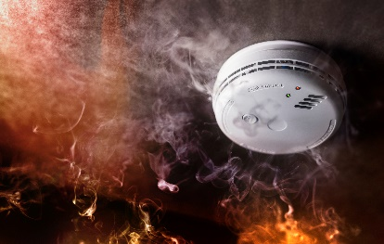 | WHY?  Backdrafting occurs when the products of combustion, including carbon monoxide, are drawn back inside the house through negative pressure.  When installing combustion appliances within a home’s conditioned space, the safest (and usually most energy efficient) type is a direct-vent, sealed-combustion unit. These appliances eliminate the possibility of backdrafting.
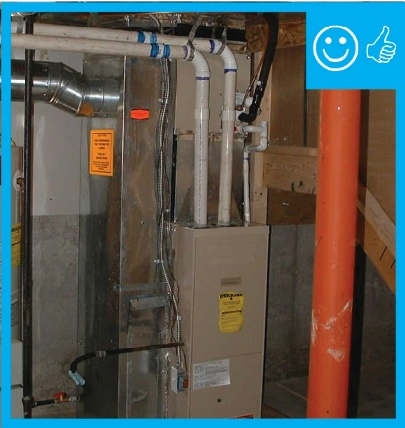 | HOW?  A direct-vent sealed-combustion furnace, boiler, or water heater brings combustion air directly from outdoors to the sealed combustion chamber through one sealed pipe and exhausts the byproducts of combustion (carbon dioxide and nitrogen) to the outdoors through a second sealed pipe. Such condensing furnaces are known as Category 4 appliances. Condensing furnaces have annual fuel utilization efficiencies (AFUE) of 90% to 98%.

