HVAC: COMBUSTION FURNACES

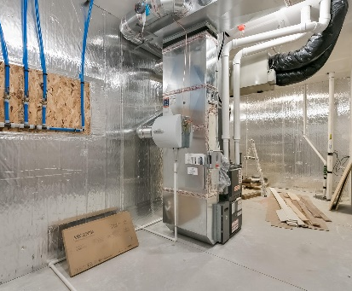 | WHAT?  Combustion furnaces, also known as forced air furnaces, are the most common heating source in America. Typically fueled by natural gas, these appliances receive combustion air from the “Combustion Appliance Zone” within the home.
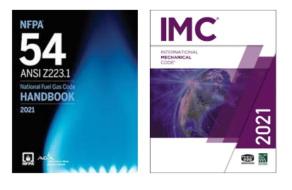 | WHY?  Combustion furnaces must be properly installed and vented to avoid backdrafting and the accumulation of pollutants. Furnaces are classified in the International Mechanical Code and National Fuel Gas Code. Understanding the descriptions of various combustion furnace types based on these codes is important with respect to safety and efficiency.
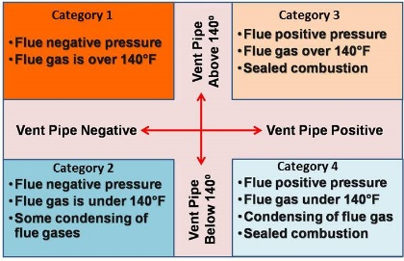 | HOW?  The International Mechanical Code categorizes combustion furnaces based on vent type:  - Direct-vent system: All air for combustion is derived from outside the home, and all flue gases are discharged outside.  - Mechanical draft system: Designed to remove gases by mechanical means, whether an induced draft or forced draft under positive pressure.  - Natural draft system: Designed to remove gases entirely by natural draft.  The National Fuel Gas Code (NFPA 54) organizes furnaces in four categories based on flue vent pressures, flue gas temperatures (relates to condensing or non-condensing), and vent pipe materials.

