HVAC: CAZ TESTING OVERVIEW

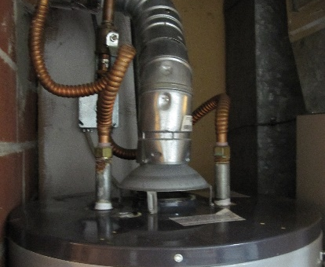 | WHAT?  Combustion appliance zone (CAZ) testing is required for atmospherically vented, or Category I, combustion appliances. These appliances rely on surrounding air for combustion. CAZ testing, which is performed by a certified rater, ensures that combustion appliances are working properly and that there is adequate room volume to ensure clean combustion.
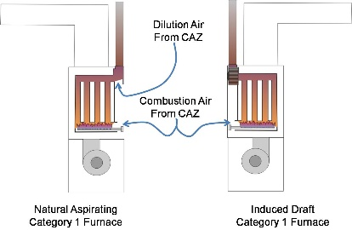 | WHY?  To ensure safe and efficient operation of Category I furnaces, boilers, and water heaters, it is critical to provide the correct amount of combustion and dilution air. Ideally, this air should come from outdoors, but it is also legal for combustion air to come from the combustion appliance zone, or CAZ, provided there is enough air volume.
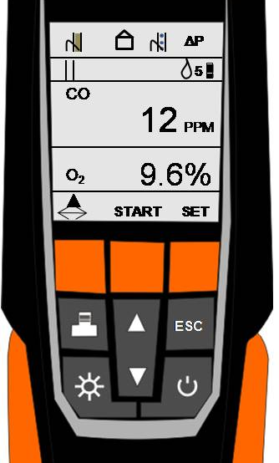 | HOW?  Atmospherically vented (aka Category I) appliances must have two fresh air supply ducts or openings installed to provide combustion air in the combustion appliance zone (CAZ). If the appliance is installed in an enclosed room, there are five possible configurations for bringing in adequate air (see slide). In any case, a certified rater must conduct a combustion safety test to verify that all combustion appliances are working properly and not venting dangerous gases into the living space.

