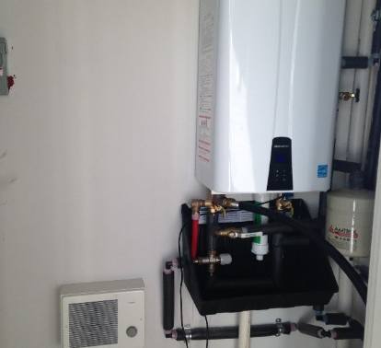 | WHAT?  According to the Energy Information Administration, water heaters can take up 19% to 32% of a homeowner’s utility bill. To reduce the amount of energy needed for water heating, a high-efficiency natural gas or propane water heater can be installed.
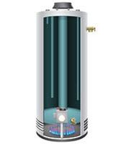 | WHY?  High-efficiency gas water heaters minimize wasted energy producing hot water. This means plenty of hot water—at lower cost.
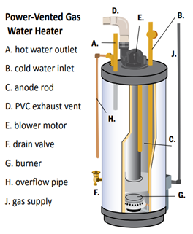 | HOW?  High-efficiency models tend to have better insulation and heat traps, as well as more efficient burners. A sealed-combustion, direct-vented gas storage system that draws its combustion air from outside and pushes exhaust flue gases outside is recommended. With a sealed combustion chamber and separate air intake, it is almost impossible for these types of water heaters to backdraft harmful flue gases back into the house. A high-efficiency power-vented gas hot water heater also can be used to avoid backdrafting.
WATER HEATERS: GAS STORAGE WATER HEATERS

