SOFFIT AND FASCIA ARE INSTALLED: REDUCING WIND WASHING

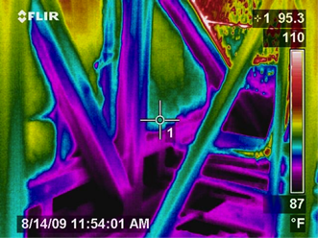 | WHAT?  Wind washing is the movement of unconditioned air around or through a new home in a way that diminishes its intended thermal performance. This can occur in attics that are vented at the soffits and where conditioned spaces border unconditioned space, such as areas that are cantilevered and air can flow through the floor joist cavities connecting the cantilevered area to the rest of the home. Indications of wind washing include cold or hot spots along exterior walls, along second-story walls that border attic spaces, over cantilevered floors, and over or along other areas of the home that abut unconditioned spaces.  Air can enter a house via natural infiltration (driven by wind and temperature differential forces) and via mechanical infiltration (driven by the heating, cooling, and ventilation mechanical systems).
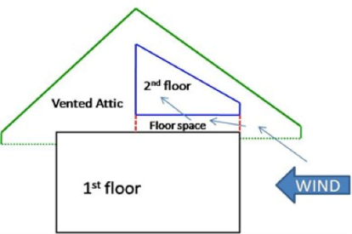 | WHY?  A whole-house draft barrier is a continuous, air-tight layer that prevents air leaks and can be integrated with other materials to function as a water barrier, thermal barrier, and vapor barrier. For example, rigid foam insulation can block thermal flow as well as air flow when seams are correctly sealed with tape, caulk, adhesives, or liquid-applied sealants, and some rigid foams even have an integrated water control layer. Drywall can serve as an interior air barrier when the seams are taped and spackled and when wiring, plumbing, and other penetrations are correctly sealed with caulk, spray foam, or gaskets; it can serve as the vapor barrier when finished with paint. Correctly installed insulation is in full contact with the air barrier layer.  Draft barriers block air flow that can hinder the new home’s thermal protection within a complete high-performance insulation system. This means less wasted energy along with enhanced comfort, quiet, and durability.
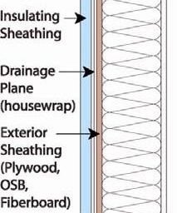 | HOW?  Identify areas likely to be susceptible to wind washing (e.g., attic soffit vents, cantilevered floors, open porch ceilings adjacent to second-story floor cavities).  - Install baffles at each rafter bay with a soffit vent to direct air flow and wind above rather than through attic insulation, then air-seal top plate-drywall seams at ceiling corners.  - Air-seal floor cavities under attic kneewalls and cantilevered floors.  - Air-seal rim joists on the home’s second story.  - Air-seal walls that split porch attic areas from the house or house attic.  Use blower door testing in combination with infrared thermography to locate areas of wind washing and to confirm successful repair.  Applicable codes include 2021 IRC, 2021 International Energy Conservation Code (IECC), DOE Zero Energy Ready Home Rev. 7, ENERGY STAR-Certified Homes Version 3/3.1 Rev. 9.

