SILL PLATES ARE INSTALLED: SEALING RIM JOISTS

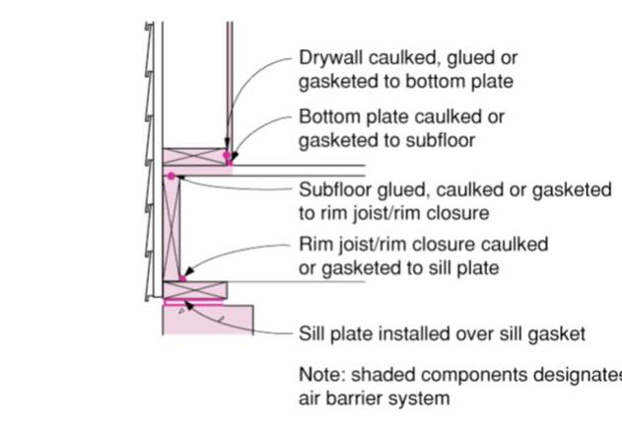 | WHAT?  After the installation of sill plates and before drywall installation, comprehensive draft protection in a new home includes installing and sealing rim joists.
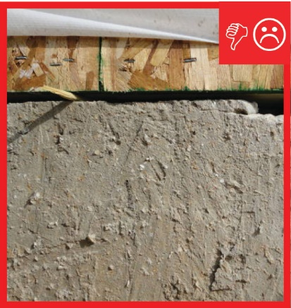 | WHY?  Poorly sealed homes are less comfortable and cost more to maintain because they open the house to drafts, cold spots, moisture, and insects. Draft protection and air-sealing minimizes air flow that can otherwise hinder a high-performance insulation system, so being meticulous here means less wasted energy along with enhanced comfort, health, and durability.
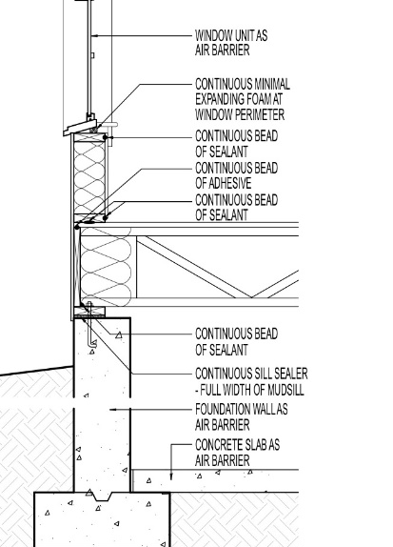 | HOW?  - Install rim joists by putting rim board on the sill plate and creating a band around the perimeter of the floor system, matching the full depth of the joists.  - Seal any seams between the sill plate and the rim joist with caulk.  - Spray-foam the entire sill plate-rim joist area for further insulation.  - Seal the hole where the anchor bolt comes through the sill plate with caulk.

