SILL PLATES ARE INSTALLED: MINIMIZE AIR LEAKAGE

WHAT?
Comprehensive draft protection includes a continuous air barrier around the whole house, along with caulking and sealing in all holes and cracks, and the installation of sill plates. Sill plates are the boards laid horizontally and directly on top of the foundation wall, usually consisting of one layer of 2x6 or 2x8 pressure-treated lumber. The band joist and floor joists rest on the sill plate, which supports the subfloor and the base plate. The sill plate is attached to the foundation wall with anchor bolts in the concrete.

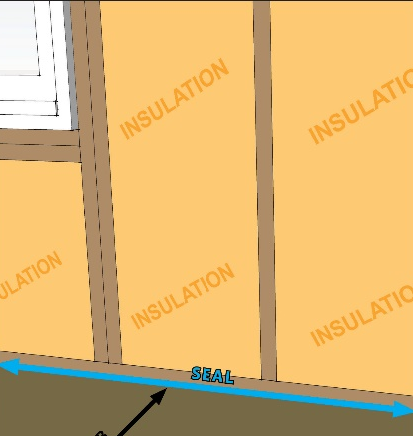 | WHY?  Poorly sealed homes are less comfortable and cost more to maintain since they open the house to drafts, cold spots, moisture, and insects. Draft protection and air-sealing minimizes air flow that can impede a high-performance insulation system, so being meticulous here means less wasted energy along with enhanced comfort, health, and durability.  Any seams where two different building components come together in the building shell can leak air, and the sill plate where the wall meets the concrete foundation is especially susceptible to air leakage. This is because the concrete surface is sometimes rough, hindering a smooth seam between the foundation and the sill plate, and because of the stack effect, which naturally pulls air in through the lower part of the building.  The best way to air-seal the sill plate is to place a sill sealer (also called a sill gasket) on the concrete before putting the sill plate down. A sill sealer is a pliable foam product that is available in varying widths up to 10 inches wide; it conforms to any irregularities in the surface of the concrete. It is a waterproof, closed-cell foam product that will both air-seal and provide a capillary break, preventing any moisture that migrates up through the concrete from reaching the wood of the sill plate. The sealer also prevents insect and rodent intrusion.
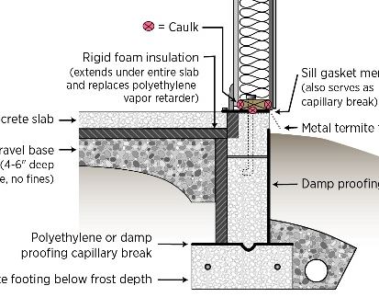 | HOW?  Lay the sill plate boards along the perimeter of the foundation. Set the edge of the sill plate back from the outside face of the foundation at a distance equal to the thickness of the exterior sheathing. Be sure to mark the locations of the anchor bolts and drill holes for the bolts. Test the boards on the sill to see if they fit and then set them aside for later.  If desired, install termite shield so that the outer edge hangs out from the exterior wall and is bent at an angle to form a drip edge and a diverter. Seal the shield to the concrete with epoxy and glue joints in the flashing with epoxy. Another option is to solder the joints.  Roll out sill sealer along the perimeter of the foundation wall, pressing down and cutting if necessary to allow anchor bolts to come through the sealer. Next, apply caulk around anchor bolts.  Lay sill board back in place over termite shield, sill sealer, and anchor bolts and secure with washers and nuts.

