TRUSSES ARE INSTALLED: RAISED-HEEL TRUSSES SAVE ENERGY IN ATTICS

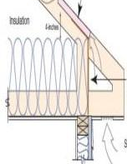 | WHAT?  Trusses are triangulated wood structures that conduct the weight of the roof and transfer it to the exterior walls. Conventional sloped attic framing or trusses are inherently shallow at the roof eaves, leaving inadequate space for comprehensive insulation, and resulting in excessive thermal losses and gains along the roof edge.  Raised-heel trusses differ from conventional trusses in that they are raised higher, extending up from the perimeter wall plate, raising the truss from the top of the perimeter wall and providing some vertical space between the wall plate and the top chord of the truss. Framing a new home with raised-heel trusses improves structural and energy performance and offers many labor and energy savings for the builder and the homeowner.
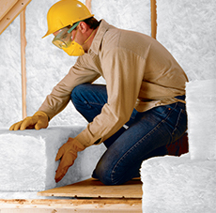 | WHY?  Framing with raised-heel trusses allows full height attic insulation to extend all the way to the attic eaves. Better insulation here translates to drier walls and lower HERS scores; improved ceiling insulation eliminates the cold spots at the top of exterior walls that conventional trusses create, resulting in a more stable temperature and a more comfortable home. Used in combination with exterior walls that are fully sheathed with plywood or OSB, raised-heel trusses help improve structural and energy performance.
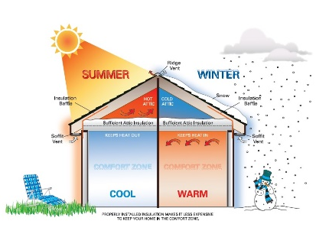 | HOW?  Raised-heel trusses can be installed more quickly than conventional roof framing, and increased spans can eliminate some internal load-bearing walls. The additional space allows for the full specified depth of insulation, better ventilation, and more flexibility in the choice of insulation. Overlapping the heels with continuous plywood or OSB sheathing eliminates the need for blocking to prevent uplift during inclement weather and saves money in materials. The design helps prevent ice dams, which occur at the eaves of conventional roofs where insulation at the wall and truss intersection is thinnest and is often compressed and where R-value is already reduced. Though extra material is used to create the trusses’ raised design, the extra cost can be offset by the need for less insulation, and energy efficiency is still not compromised. Applicable codes include IRC 2021 and IBC 2021.

