MOISTURE BARRIER AND FLASHING: KICK-OUT FLASHING, STEP FLASHING, OR ROOF-WALL WATER DEFLECTOR

WHAT?
Roofs are vulnerable to water leaks and damage where they intersect walls. While wood siding may quickly show evidence of this water intrusion with peeling paint or stains, some wall claddings like fiber cement, vinyl siding, and brick veneer can mask indications of damage for years.

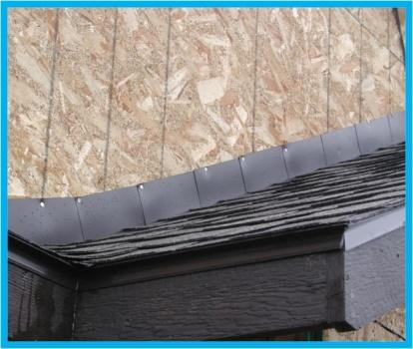 | WHY?  Roof-wall water deflectors help drain water away from a new home’s high-risk corners where walls meet roofs. These deflectors are part of a comprehensive set of measures that minimize the risk of water damage in the home. Kick-out flashing is not only good for the roof and rain gutter system—it also prevents water damage to a new home’s roof, siding, interior ceiling and walls, concrete or stucco walls, and beyond to pavement, sidewalk, and landscaping. Areas like the roof, siding, and interior could develop harmful mold if water damage continues.
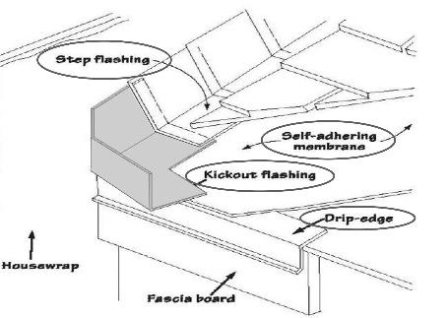 | HOW?  Apply some waterproofing where the bottom of the roof meets the exterior wall—at least 4 inches in every direction from its framing—as well as below the fascia. Blend the waterproofing into the housewrap using the correct overlaps.  Apply waterproofing along the eaves and fold over its bottom 2 inches onto the fascia.  Apply some more waterproofing to cover up the entire joint where the wall meets the roof; then, extend this waterproofing about 8 inches up the wall and onto the roof.  Install roofing felt over the roof and run it up the wall at least high enough to where the head of the step flashing will be located. Put in a starting strip of roofing and place the kick-out flashing at the location of the initial piece of the step flashing. Verify that it hangs over the eaves enough so that water will be directed away from the wall and roof, safely into the gutter.  Weave the step flashing in place, alternating as needed so that every piece of it lies over the lower one by a minimum of 2 inches. Make certain that the step flashing does not come out from under the shingles.  Install one more strip of waterproofing on top of the step flashing, then cut a small slit in the kick-out flashing and leave a 2-inch space between the waterproofing and the roofing.  Install the housewrap on the wall going from the bottom to the top, applying flashing tape to ensure smooth drainage. Be sure to overlap the lower courses of the housewrap under the upper ones and make a slit for the kick-out flashing.  ENERGY STAR specifies step and kick-out flashing at all roof-wall intersections, extending ≥ 4 inches on the wall surface above the roof deck, and integrated with the drainage plane and using a self-sealing bituminous membrane or equivalent at all valleys and roof deck penetrations.

