HOUSE IS WRAPPED IN VAPOR BARRIER: DRAINAGE PLANE BEHIND EXTERIOR WALL CLADDING
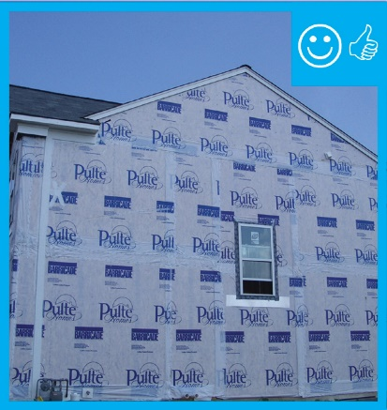 | WHAT?  After the roof assembly is completed, a water-resistant barrier should cover the entire house and the seams should be taped to provide a complete drainage system. This continuous drainage plane should go behind the exterior cladding on the walls of the new home to keep water out of the wall cavities.
WHY?
When some moisture gets past the siding, a wall water barrier provides a path for it to safely drain down and away from the wall and gives the home comprehensive moisture protection.

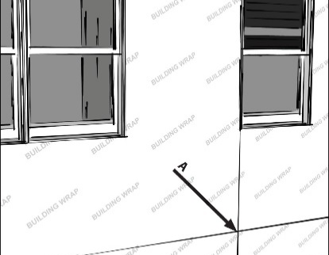 | HOW?  This barrier can be one of the following:  - Housewrap that is lapped shingle-style  - Water-resistant rigid foam insulation that is taped or sealed at all seams  - A wet-applied moisture-resistant coating  - Other water-resistive barrier materials that are recognized by the ICC-ES or another accredited agency.  The water barrier must be thoroughly sealed and flashed at:  - All exterior wall openings and penetrations (e.g., windows, doors, water spigots, exhaust vent outlets, HVAC condensate lines, light fixtures, and receptacles)  - All wall intersections (e.g., roofs, foundations, and other transitions).  Install an additional bond-break drainage plane layer behind stucco and non-structural masonry wall cladding assemblies.  Before installing siding, verify that the weather-resistive barrier or rigid foam sheathing is correctly installed and correctly integrated on exterior walls with wall flashings to direct water away. Seams should be neatly taped, and the tape must adhere uniformly to the substrate without peeling or "fish mouths" (i.e., folds in the tape that create an opening that does not adhere to the housewrap or rigid foam sheathing).  Applicable codes include DOE Zero Energy Ready Home Rev. 7, 2021 IRC, and ENERGY STAR-Certified Homes Version 3/3.1 Rev. 9.

