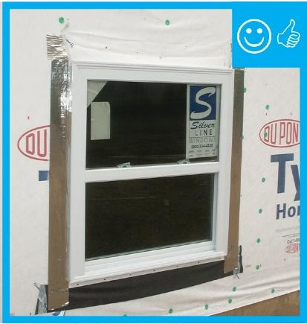 | WHAT?  Windows and doors disrupt a wall’s water protection layer and present spots that are vulnerable to leakage. Properly installed flashing is crucial to stop water intrusion around doors and windows. Pan flashing is installed at the sills of windows and doors—the places that are most vulnerable to water intrusion—and it has to integrate with jamb flashing and overlap the wall’s water barrier below in order to collect and direct any water that may leak through or around the opening back out to the exterior.
WHY?
Window and door water barriers help drain water away from all the openings in the new home’s wall system and are part of a comprehensive set of measures that minimize the risk of water damage.

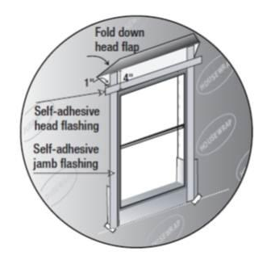 | HOW?  Apply properly lapped flashing around window and door openings to direct water out of—not into—the wall cavity.  - Apply rigid, flexible, or fluid-applied pan flashing at sills  - Put in window or door  - Apply side flashing that reaches over the pan flashing  - Install top flashing that reaches over the side flashing  - Correctly integrate all flashing with the drainage plane layer (which could be housewrap, taped weather-resistant sheathing, a liquid-applied coating, or another approved material).  Confirm the window and door flashing is correctly installed before siding is installed.

