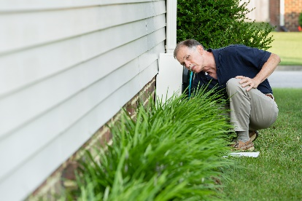 | WHAT?  If not drained away from the house, the high volume of water coming off the roof can rapidly saturate the soil surrounding the building and wick through the foundation to the interior. A variety of subsequent problems involve: mold and rot, indoor air quality, and building durability.
WHY?
Water management practices such as sloping grade away from house and installing gutters, perimeter drain pipe, a capillary break, and free-draining soils or drainage mat protect the foundation from water saturation.

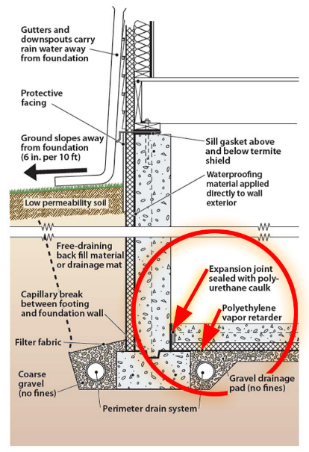 | HOW?  - Install appropriately sized gutters and downspouts.  - Connect the downspouts to piping that will carry the water to a sloping final grade farther than 5 ft. from the foundation or to an underground catchment system farther than 10 ft. from the foundation and that is not connected with the foundation drain system.  - Or, install a rainwater harvesting system with a drainage system to handle overflow.  - Or, construct a grade-level rock bed with a waterproof liner and drain pipe to collect water draining from the roof.  Applicable codes and standards for gutters and downspouts include ENERGY STAR Certified Homes, Version 3/3.1 (Rev. 09), DOE Zero Energy Ready Home (Rev. 07), EPA Indoor airPLUS (Rev. 04), 2021 International Residential Code (IRC), 2021 International Wildland-Urban Interface Code (IWUIC), and National Fire Protection Association (NFPA) 1144. Install protection from water splash damage with homes without gutters (per EPA Indoor airPLUS).
FOUNDATION DRAIN: GUTTERS AND DOWNSPOUTS

