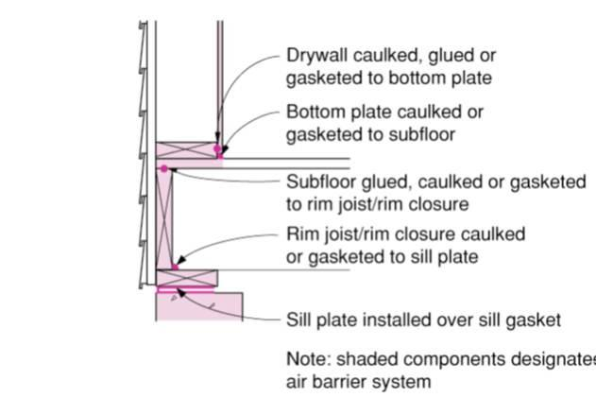 | WHAT?  Air sealing above-grade sill plates that are adjacent to conditioned space can minimize air leakage and helps provide a continuous air barrier where the wall meets the foundation.      
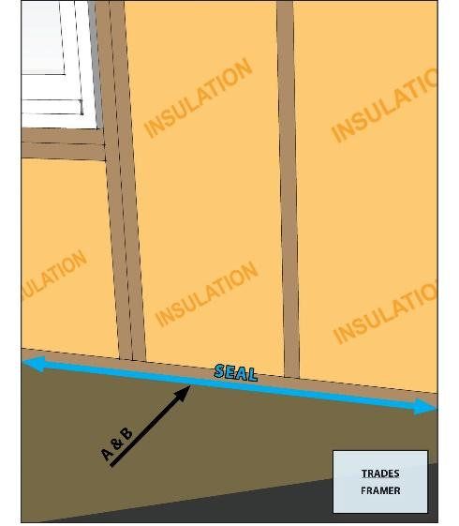 | WHY?  For a home to perform efficiently, the walls, ceiling, and foundation must be connected to provide a continuous air barrier. Any seams where two different building components come together in the building shell represent a potential source of air leakage. The sill plate where the wall meets the concrete foundation is especially susceptible.
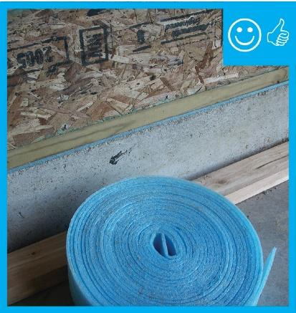 | HOW?  To air seal the junction between the sill plate and foundation, use a pliable closed-cell foam product that can be rolled out over the concrete along the foundation perimeter, where it conforms to any irregularities in the surface. All joints in the sill plate should be sealed with caulk, and the top of the sill plate should be sealed to the rim joist with a bead of caulk.
FRAMING: FLOOR FRAMING: AIR SEALING SILL PLATES

