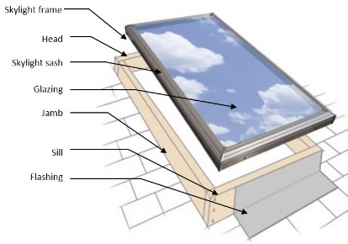 | WHAT?  Flashing around a skylight with an existing roof, the intent should be to cut back the existing shingles as little as needed to perform the work. Flashing should be properly integrated with new or existing layers of roof sheathing membrane, underlayment, rigid foam, and roof cladding.
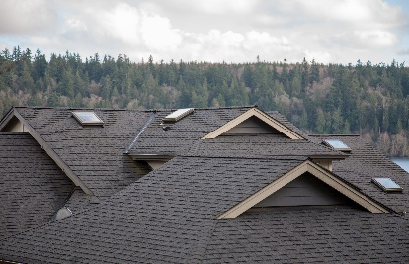 | WHY?  Skylights are penetrations through a roof’s water control layer. They represent a weak spot in the roof’s water management protection system where water could leak into the attic, potentially causing significant damage. During reroofing, installers should determine if proper flashing and other water management details are in place to prevent future water leaks.
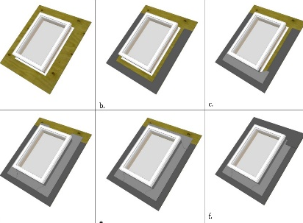 | HOW?  When replacing the flashing for a curb-mounted skylight, expose the roof deck by cutting away the shingles and underlayment 2 inches back from the edge of the curb on the sides and 3 inches on the top and bottom of the skylight. Wrap the sill and jamb with self-adhered membrane flashing and tuck it below the roof shingles, but above the underlayment. At the head, diagonal slits should be cut in the roofing underlayment so the membrane can be attached directly to the roof deck. Note that details are slightly different for deck-mounted skylights, as a larger area must be cut away.
ROOFING: FLASHING AROUND A SKYLIGHT WITHOUT ROOF REMOVAL

