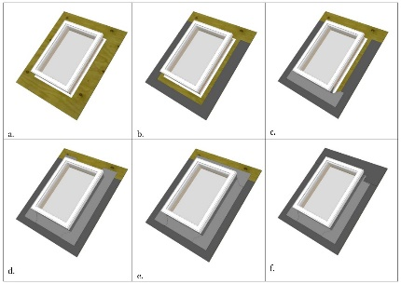 | WHAT?  Flashing around a skylight should be properly integrated with new or existing layers of roof sheathing membrane, underlayment, rigid foam, and roof cladding. The flashing consists of strips of metal or self-adhered flexible membrane that provides a weatherproofing layer between the shingles and the skylight.
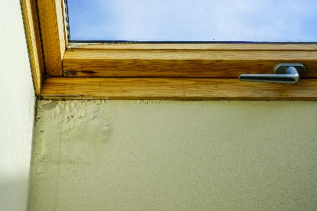 | WHY?  Skylights are penetrations through a roof’s water control layer. They represent a weak spot in the roof’s water management protection system where water could leak into the attic, potentially causing significant damage. During reroofing, installers should determine if proper flashing and other water management details are in place to prevent future water leaks.
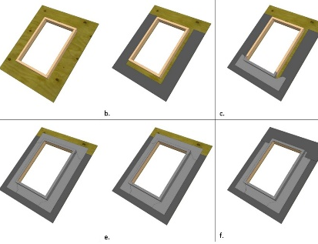 | HOW?  Flashing and underlayment are installed from the bottom up so upper layers overlap lower layers to shed water away from the roof. First, roof underlayment is installed around the bottom and sides of the curb or deck. Next, install self-adhered membrane flashing over the underlayment at the bottom, then sides of the curb. At the top of the unit, install membrane flashing directly to the wood deck. Finally, install the roofing underlayment over the top of the flashing.
ROOFING: FLASHING AROUND A SKYLIGHT WITH ROOF REMOVAL

