Primary Window Components
Glazing technology is combined with a spacer system and a gas fill between the panes to produce an energy-efficient Insulating Glass Unit (IGU). An IGU is assembled with frame and operability options to form the complete window assembly. Some integrated technological innovations that appear in today’s fenestration products are listed below.

• Multiple layers of glass or plastic film
• High performance glazing low-e or solar control coatings
• Low-conductance gas fills
• Warm edge spacers
• High performance frames

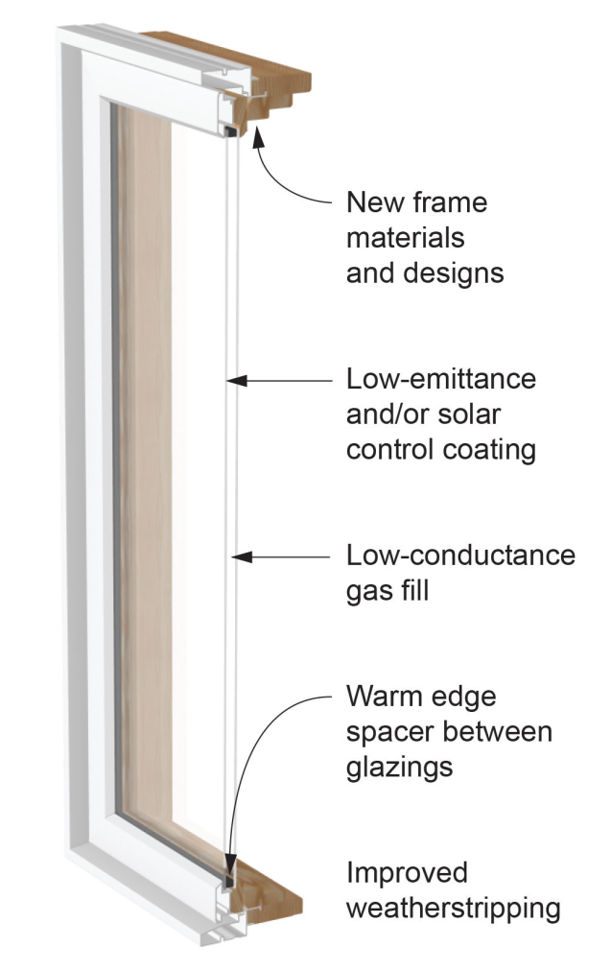
Figure 1 Energy Efficient Window Components
A variety of window technologies can improve window energy efficiency, including gas fills, low-E coatings, and high-performance frame options. How these technologies affect a window's energy performance depends on the sum of all parts. This is where whole window energy ratings help, accounting for the combined effect of glazing, spacers and frame (thermally improved). The only reliable way to determine whole-window energy properties are the ratings certified by the National Fenestration Rating Council (NFRC). In most jurisdictions across the United States, building energy codes require that windows bear the NFRC label so that the code compliance of their energy ratings can be verified.
The following picture shows the energy efficient window components along with the other window assembly components that may be important in installation.
