Physical Measurements and Rating Labels

Heat Gain and Heat Loss
Windows, doors, skylights can gain and lose heat through:
- Direct conduction through the glass or glazing, frame, and/or door
- The radiation of heat into a house (typically from the sun) and out of a house from room-temperature objects, such as people, furniture, and interior walls
- Air leakage through and around them.
Many of these properties can be measured for each window and rated according to the following energy performance characteristics:
- U-factor is the rate at which a window, door, or skylight conducts non-solar heat flow. It's usually expressed in units of Btu/hr-ft²-ºF. For windows, skylights, and glass doors, a U-factor may refer to just the glass or glazing alone. NFRC U-factor ratings, however, represent the entire window performance, including frame and spacer material. The lower the U-factor, the more energy-efficient the window, door, or skylight.
- Solar heat gain coefficient (SHGC) is the fraction of solar radiation admitted through a window, door, or skylight -- either transmitted directly and/or absorbed, and subsequently released as heat inside a building. The lower the SHGC, the less solar heat it transmits and the greater its shading ability. A product with a high SHGC rating is more effective at collecting solar heat during the winter. A product with a low SHGC rating is more effective at reducing cooling loads during the summer by blocking heat gain from the sun. The building’s climate, orientation, and external shading will determine the optimal SHGC for a particular window, door, or skylight.
- Air leakage is the rate of air movement around a window, door, or skylight in the presence of a specific pressure difference across it. It's expressed in units of cubic feet per minute (cfm) per square foot of frame area (cfm/ft²). A product with a low air leakage rating is tighter than one with a high air leakage rating.
- Visible transmittance (VT) is a fraction of the visible spectrum of sunlight (380 to 720 nanometers), weighted by the sensitivity of the human eye, that is transmitted through the glazing of a window, door, or skylight. A product with a higher VT transmits more visible light. VT is expressed as a number between 0 and 1. The VT you need for a window, door, or skylight should be determined by your home's daylighting requirements and/or whether you need to reduce interior glare in a space.
- Light-to-solar gain (LSG)is the ratio between the SHGC and VT. It provides a gauge of the relative efficiency of different glass or glazing types in transmitting daylight while blocking heat gains. The higher the number, the more light transmitted without adding excessive amounts of heat. This energy performance rating isn't always provided.

Window Rating Systems
The National Fenestration Rating Council (NFRC) operates a voluntary program that tests, certifies, and labels windows, doors, and skylights based on their energy performance ratings. The NFRC label provides a reliable way to determine a window's energy properties and to compare products.
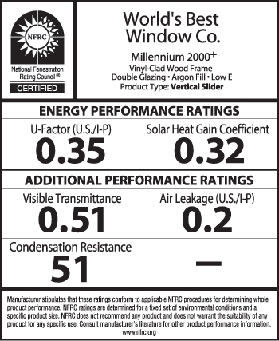
The NFRC label can be found on all ENERGY STAR® qualified window, door, and skylight products, but ENERGY STAR bases its qualification only on U-factor and solar heat gain coefficient ratings, described above.

