Correct Window Installation Methods

Quite simply, windows are only as good as their installation. Proper installation will:
- Protect from water damage. Windows should form a continuous water barrier where they meet the wall. With improper installation, water may penetrate and cause damage—often unseen— in the wall.
- Limit air leakage. Windows must complement the wall's air barrier. Even tiny cracks around the window frame can lead to substantial heat loss unless properly sealed.
- Prevent condensation. Windows must complement the wall's vapor barrier to prevent water vapor from passing around a window frame. If vapor condenses on cold surfaces between the frame and the wall, rot or other damage may follow.
Due to these potential issues, windows should be installed by skilled and experienced individuals.

Quality Installers
The first place to inquire about quality installers is the manufacturer from whom you are purchasing the windows. Manufacturers may have recommendations of in-house or 3rd party installers or installation certification programs.
There are standards for proper window installation, and installers are well advised to follow these along with the manufacturer's product-specific installation requirements. The most prominent of these standards is ASTM Standard E 2112. Trained installers are likely to be familiar with this standard. Window manufacturers may have training and certification programs for installers of their own products. Installers may also be certified by nationwide programs such as:
- InstallationMasters™: www.installationmastersusa.comexit disclaimer includes a directory of certified installers in the United States.
- WindowWise National Certification Program: www.windowwise.comexit disclaimer includes a directory of certified installers in Canada.

Installation Guidance
The Following information has been excerpted from the Building America Solution Center: https://basc.pnnl.gov/.
- Follow the manufacturer’s installation instructions when installing the windows to avoid voiding the warranty. Some warranties require that you use an installer certified by the manufacturer.
- Properly install windows to keep air and moisture out. See the guide Fully Flashed Window and Door Openings.
- Properly air seal around window rough openings. See the guide Window and Door Rough Openings.

Fully Flashed Window and Door Openings
Windows and doors are an interruption in the wall’s housewrap or insulated sheathing drainage plane and thus are a vulnerable spot for water leakage. Many a homeowner has suffered from water intrusion around doors and windows, often not discovered until considerable damage has been done within the wall. The wall framing around windows and doors must be protected from any water that finds its way behind the siding at these locations and the water must be directed out to prevent damage to the rest of the wall. Properly installed flashing that is integrated with the other elements of the wall can help prevent this.

Flashing materials may be installed by insulators, framers, or subcontractors or vendors hired specifically to install the windows and doors. This task should be included in the contract for the appropriate trade depending on the workflow at the specific job site.

Other Considerations: When designing the home, walls and doors should be located under overhangs or porches whenever possible; these features protect against rain and snow and also minimize unwanted solar heat gain by blocking out high summer sun.

How to flash windows and doors
- Cut the housewrap covering the rough opening in the shape of a modified “I.”
  - Fold the side and bottom flaps into the window opening and secure.
  - Above the window opening, cut a head flap. Fold it up to expose the sheathing and loosely tape it in place out of the way.

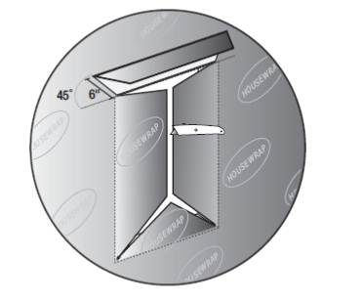
- Install back dam and self-adhesive flashing at sill. Tape the corners.

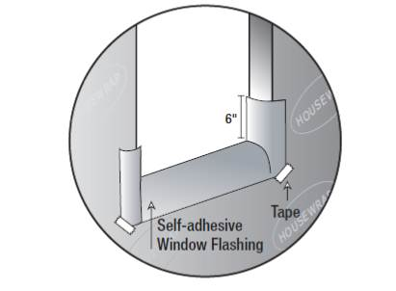

For pan or sill flashing, use formable flashing, a stretchable self-adhered membrane that bends at corners so one continuous piece can be used to cover the bottom and sides of the sill.
- First install a back dam consisting of a strip of wood or beveled siding nailed along the back (inside) edge of the rough opening (over the flap of housewrap). Sloped pans are required if the sill depth is greater than 6 inches according to ASTM E212207.
- Cover this with the membrane. Begin pressing in the middle of the sill and work toward the sides, removing adhesive covering strips as you go. Make sure to press the membrane tightly into the corners to avoid tears later when the window is installed.

Other options for pan flashing include self-adhered non-elastic membrane, which must be cut and patched at corners, and two-piece rigid manufactured pan flashing, which comes with a built-in back dam that must be protected from breakage during window installation.

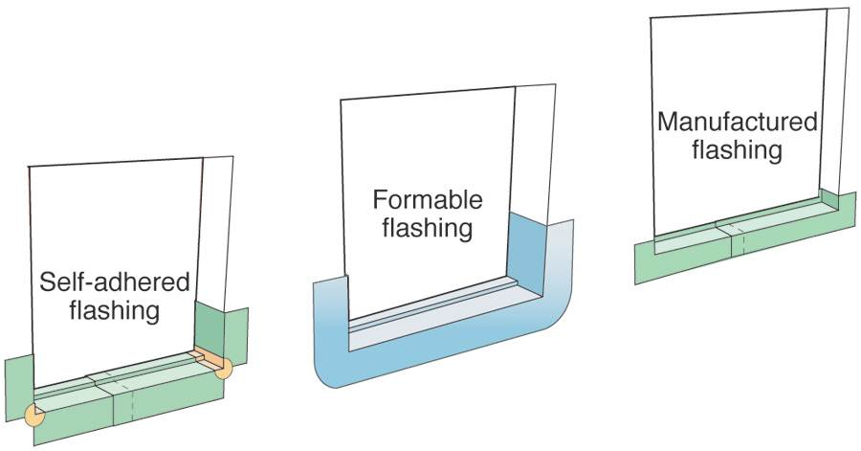

- Caulk the outside edges of the head and side jambs and install the window.
• Do not caulk across the sill.
• Install the window plumb, level, and square following manufacturer’s specifications.

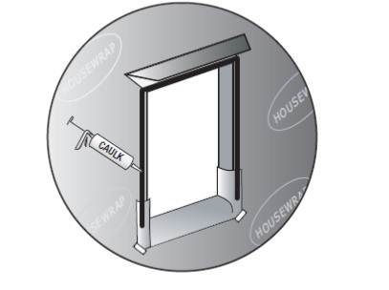
- Install jamb and head flashing.
  - Install self-adhesive jamb flashing extending 4 inches above the top of the head flange and even with the bottom of the sill flashing.
  - Install self-adhesive head flashing extending 1 inch beyond the jamb flashing.
  - Unfold the housewrap and lay over the head flashing. Tape bottom edge of housewrap across the top window flange and tape down corner seams of housewrap.

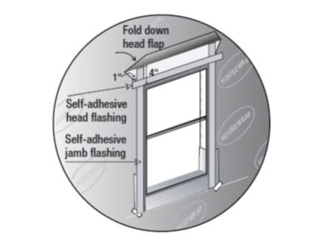
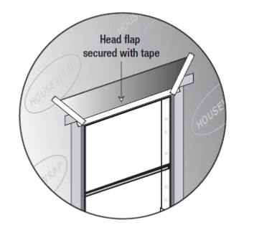

- On the interior side of the window, seal the gap between the window and the rough opening with backer rod or non-expanding foam and caulk.

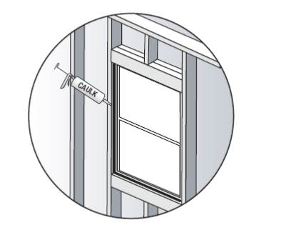

- Install trim that has been painted or primed on all sides. Above top trim, install cap flashing that extends past trim. Cover top edge of cap flashing with adhesive membrane strip. Cover top edge of membrane with sheathing tape.

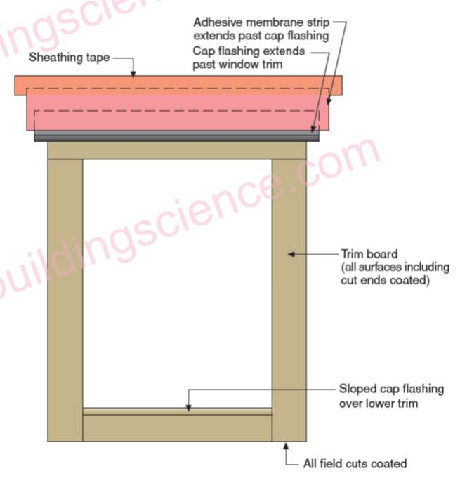

How to Flash a Door
- Flash door head and jambs as described above for windows or in accordance with door manufacturer’s instructions.
- For sill flashing, see door manufacturer’s instructions.
  - For houses with concrete slab floors, form a seat in the concrete slab to act as a “pan flashing”.
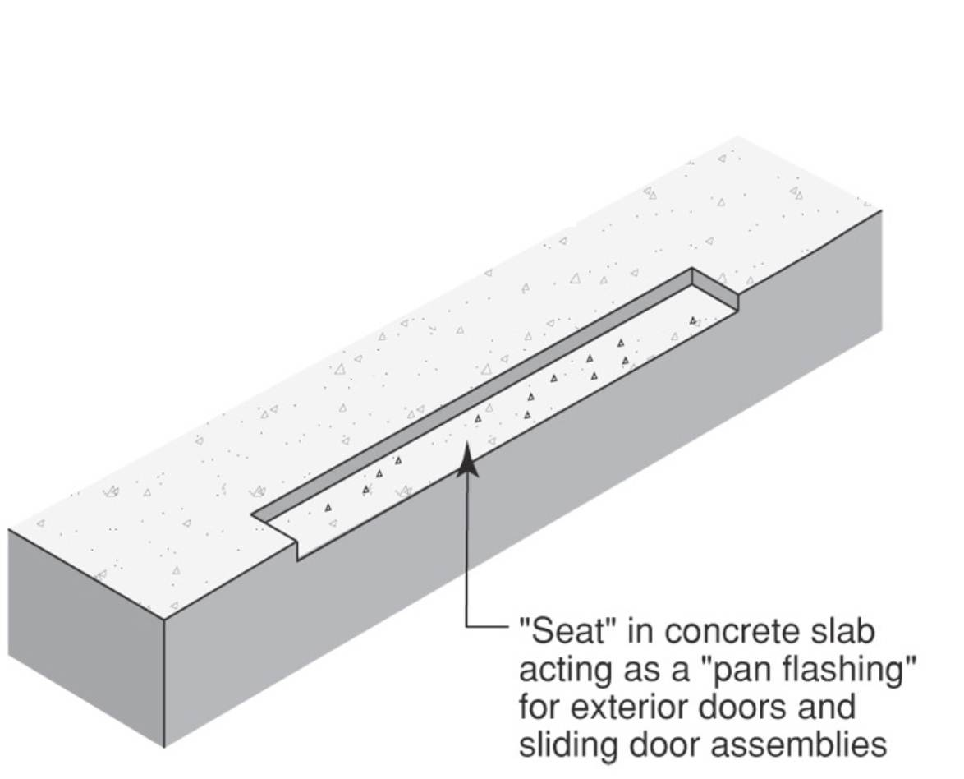

  - Install pan flashing that is integrated with the housewrap. ASTM E2112-07 recognizes several flashing materials and methods including single-piece sill pans formed from rigid sheet metal or plastic, multi piece sill pans formed from rigid sheet metal or plastic, flexible membrane, or combinations of rigid corners connected by flexible membrane.

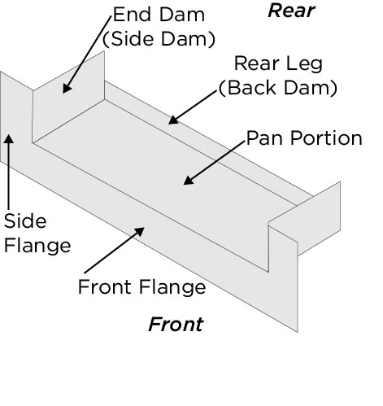

Material Options for Air Sealing Window and Door Rough Openings
Too often, an attempt to seal around a window or door unit is made by stuffing the gap with fiberglass insulation. However, fiberglass is not an air barrier; air can readily seep through the insulation fibers. Instead, the gap should be filled with one or more of the following materials (DOE 2000):

- Backer rod comes in both open- and closed-cell varieties. Only closed-cell products (usually made of polyethylene foam) should be used for sealing window and door rough openings, as open-cell foams can absorb and hold moisture. Closed-cell backer rod is typically stocked at hardware stores in 1/4 to 1-1/2-inch-diameters, and sold by the foot from a reel. Larger diameter backer rod (up to 4 inches) is also available in 6- or 7-foot lengths. Always use backer rod that is wider than the gap, so it can be pressed firmly into the gap and create a tight seal.

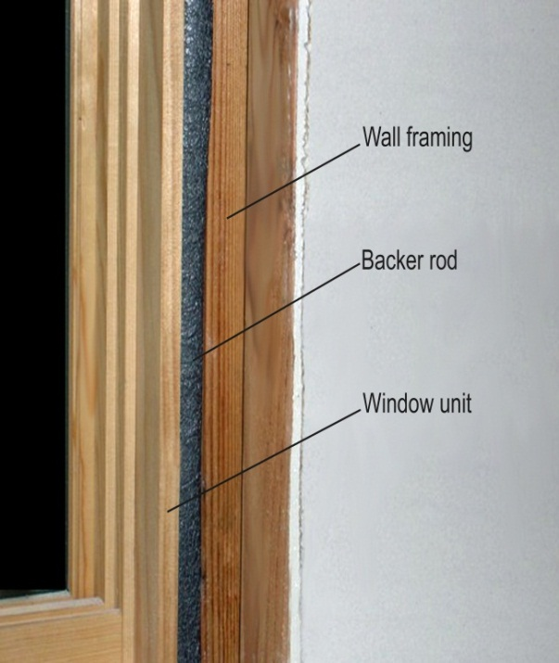

Figure 1. Closed-Cell Backer Rod for Air Sealing Window and Door Rough Openings (Photo courtesy Digital Learning Labs, LLC)

- Caulk can be used to seal smaller gaps less than 1/2 inch wide. Caulk has the advantage of providing a more positive seal in irregular gaps, and when applied carefully, can create a tight seal around the shims used to install window and door units. For best results, use a silicone or polyurethane sealant that will shrink less than acrylic products when fully cured (Jackson 1997).

- Nonexpanding foam can be used to quickly and effectively seal the gap between the wall framing and window or door unit. It is important to use a nonexpanding product specially formulated for use as a window or door sealant. Ordinary expanding foam can swell with enough force to distort the jambs, and cause problems with operating the windows and doors. Use of ordinary expanding foam will often void window and door warranties.

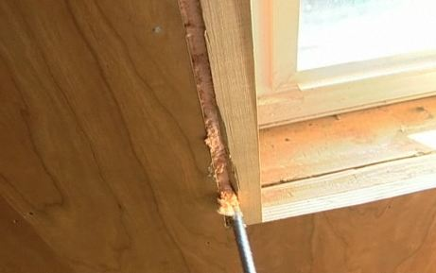

Figure 2. Application of Window and Door Nonexpanding Foam Sealant. Although nonexpanding foam can quickly and effectively seal gaps between the jamb and the wall framing, only use nonexpanding foam sealants that are designed specifically for windows and doors. (Photo courtesy of Building Media)

Guidance for Air Sealing Window and Door Rough Openings

Air sealing window and door rough openings is typically done by the insulation contractor, but in some cases it may be done by the window and door installer or by the finish carpenter prior to installing window and door trim.

With the window or door unit permanently installed in the rough opening, air seal the opening as follows:

1. Trim back the shims securing the window or door unit to the wall framing. If possible, try to cut these back behind the interior face of the wall and jambs, so that sealant can be applied over the shims for a tighter seal.

2. Apply the sealant toward the interior edge of the window or door unit. Using this approach, the gap to the exterior can drain freely and will be pressure equalized with the exterior, which limits the potential for an air pressure difference to force water into the joint (BSC 2009).

- With backer rod: Press the backer rod into the gap between the wall framing and the window or door unit. Use a flat bar to push it in. Apply even pressure; don't force it in, or the tool will tear the backer rod. Push the backer rod to an even depth. If caulk will be applied over it, take care to create an even surface that will provide a uniform substrate for the caulk.
- With caulk: If the gap is less than 1/2 inch wide, apply caulk over the backer rod for a tighter seal. Caulk should always be applied against backer rod, not just squeezed into the gap. Tool the bead against the backer rod. This will create an hour-glass shape (see Figure 3 below), which allows the sealant to expand and contract over time without cracking. Without the backer rod, the bead of caulk would be too thick and would be prone to cracking when it cures, and it would be resistant to flexing with movements in the building materials of the wall system as they change dimension with seasonal changes in temperature and humidity.

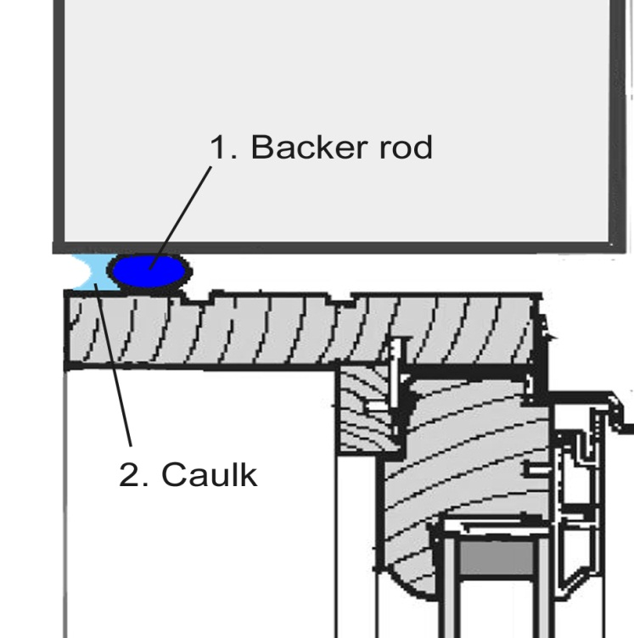

Figure 3. Caulk Applied Against the Backer Rod to Seal a Window Rough Opening. When tooled, a bead of caulk (light blue) should have an hour-glass shape when applied against backer rod (dark blue). This profile allows the caulk to expand and contract over time without cracking. (Photo courtesy Digital Learning Labs, LLC)

- With nonexpanding foam, wear gloves when applying spray foam; the foam has an especially aggressive bond that will adhere to skin. Insert the spray nozzle about half an inch into the gap between the wall framing and the window or door unit. Keep the spray nozzle moving at a steady speed while applying the foam: Too slow and the foam will fill too much of the cavity; too fast will result in gaps in the bead.

3. With all types of sealant materials, pay close attention near the shims that hold the unit in the rough opening. It is important that the sealant fit tightly around these obstacles in the sealant path.

