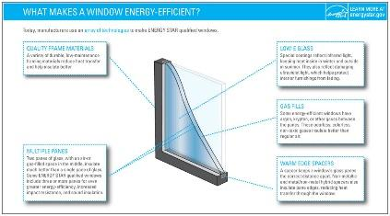 | WHAT?  ENERGY STAR® is a joint program of the Environmental Protection Agency (EPA) and the Department of Energy (DOE). Its goal is to help consumers, businesses, and industry save money and reduce their carbon footprint through the adoption of energy-efficient products and practices. Windows, doors, and skylights can be certified under the Energy Star program. Products bearing this label are verified by the National Fenestration Ratings Council and must meet certain thresholds to qualify.  High-efficiency ENERGY STAR-rated windows perform at least 15% better than a standard window and have an insulating value of R-3 or higher.
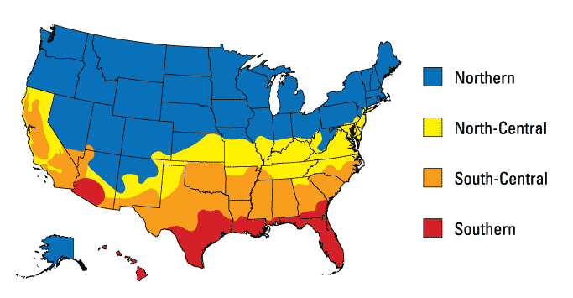 | WHY?  Windows, doors, and skylights are typically weak points in a building envelope that allow more transfer of heat. This can significantly impact how much energy is required to heat and cool the home, as well as how comfortable rooms are. Specifying Energy Star-labeled products can reduce energy use and help create a more comfortable home. Savings are greatest in more severe, colder climates.
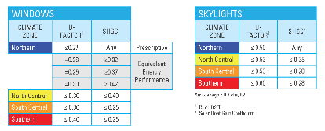 | HOW?  Ratings for Energy Star windows, doors, and skylights are based on U-factor and Solar Heat Gain Coefficient, or SHGC. Recall that U-factor is the inverse of R-value. It is a measure of how well a unit conducts heat. The lower the U-factor, the less heat it conducts and the better it performs.  SHGC is a measure of fraction of solar radiation admitted through a window, door, or skylight and subsequently released as heat inside a home. The lower the SHGC, the less solar heat it transmits.  Performance criteria vary based on the climate zone, with more stringent criteria set for colder northern zones.

