Building Science Education Solution Center – Electrical Panels
Proficiency Level 2: Understand
Learning Objective 2.1:
- Know how to determine a home’s electrical panel size.
Lecture Notes 2.1:
One of the first steps that should be undertaken while considering an upgrade to a heat pump is an assessment of the home’s electrical panel size. Most new homes have an electrical service of 200A. However, some older homes may have electrical service of less than 100A. Determining the size of the electrical panel along with a load calculation of the home’s electrical end-uses is necessary for evaluating whether a panel upgrade is needed for the installation of the ASHP.
The size of the home’s electrical panel can be determined by checking:
- The amperage rating printed on the home’s electrical meter, which is typically located outside the home
- The amperage rating printed on the label of the home’s main electrical panel
- Capacity of the main breaker
In cold climates, a minimum of 100A is recommended for installing a heat pump. Upgrading to 200A is advisable if installing electric water heating, solar photovoltaic (PV) panels and electric vehicle (EV) charging equipment at the same time or in the future.

Learning Objective 2.2:
- What are the components in a typical electrical panel?
Lecture Notes 2.2:
Most residential electrical panels consist of typical components, following the flow of electricity from the grid to end uses:
- Service wires carry electricity through overhead or in-ground lines from the electrical grid. There are three service wires: two hot wires and a neutral wire. Service wires attach to the utility meter, usually on the outside of the home.
- The utility meter measures the amount of electricity flowing into the home. On the other side of the meter, the service wires are attached to a main breaker and bus bars. After the electricity completes its circuit through the home, the service wires carry unused electricity back through the meter, which calculates the amount of energy consumed.
- The main breaker is a switch that can be flipped to cut power to everything downstream i.e., the whole building. Main breakers are designed to handle a certain amount of electrical current, usually 100 to 200 amp service for a residential home. If the service amperage is exceeded, the main breaker will trip and will cut power to the home to protect the circuits and appliances. Electricity flows through the main breaker to two main bus bars.
- Main bus bars are large electrical terminals that carry electricity to the circuit breaker. In a typical US home, there are two main bus bars and each supply 120 Volts of electricity.
- Circuit breakers attach to the main bus bars, controlling the flow of electricity into the branch wiring, as well as serving as a safety device designed to protect against overcurrent or short circuit. Like the main breaker, circuit breakers are designed to handle a certain amount of electrical current (known as amperage rating), which is printed on a toggle switch. If that current is exceeded or the breaker experiences a short circuit (an accidental circuit with no intentional load), the circuit breaker cuts power to that circuit. Single pole circuit breakers attach to a single main bus bar provide 120 Volts to appliances such as lighting and standard appliance outlets. Breakers that attach to both main bus bars, called double pole circuit breakers, provide 240 Volts to larger appliances like clothes dryers, electric vehicle chargers, and heat pumps.
- Branch wiring carries the electricity from the circuit breaker through a “hot” wire (often black or red wire) to the appliance and returns the unused electricity back to the neutral bus bar through the neutral wire (often white wire). Ground wires (often bare or green) connect the appliance to the ground bus bar, which provides a low resistance path back to the panel in the case that the electricity takes an unintentional path.
- An electrical load is any component of a circuit that consumes energy, like an appliance plugged into an outlet or light fixture. Each load will have connectors or connecting wires for hot, neutral, and ground wires. Electricity flows through the hot wires, powers the load, and unused electricity is carried back to the neutral bus bar.
- The neutral bus bar is attached to the neutral service wire and used to return the electricity back to the electrical grid.
- The ground bus bar is attached to ground rods that ensure the electricity always has a safe path to ground, to prevent electrocution.
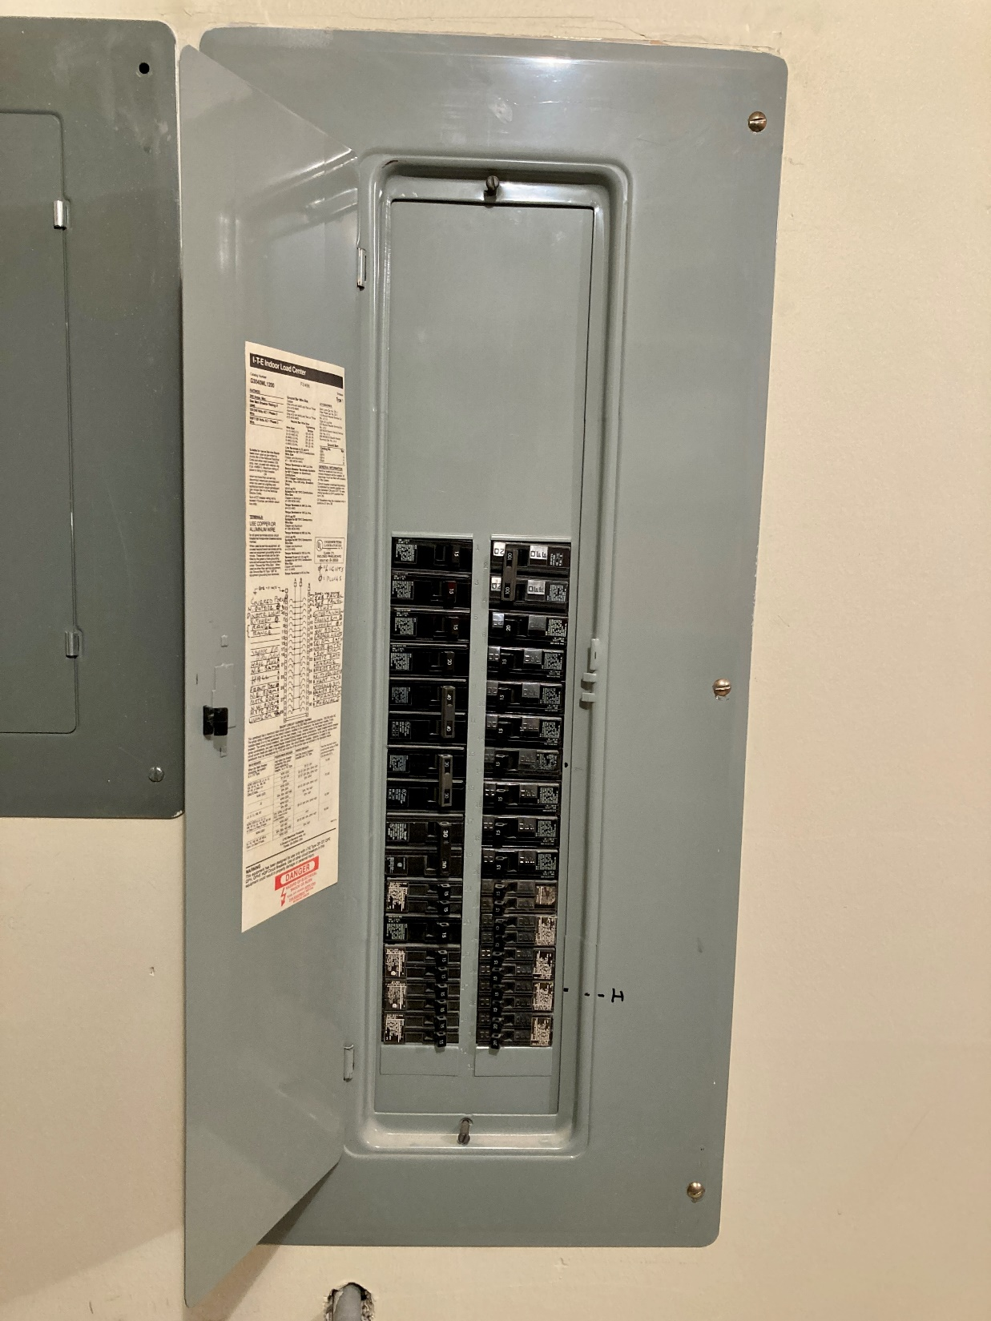
Figure 1 - A residential electrical panel with the access door open. A legend is found on the inside of the door that indicates the loads associated with each circuit breaker
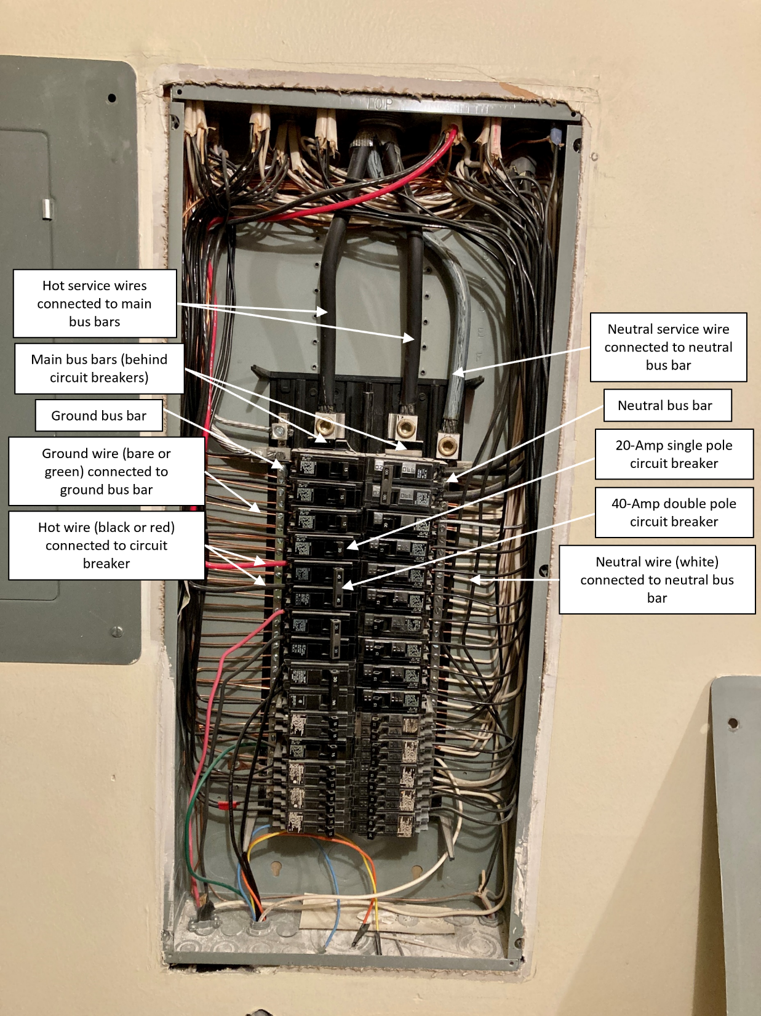
Figure 2 – A residential electrical panel with the cover removed. Typical components are labeled. The main breaker is not shown in this picture as it is located outside the home near the electrical meter.
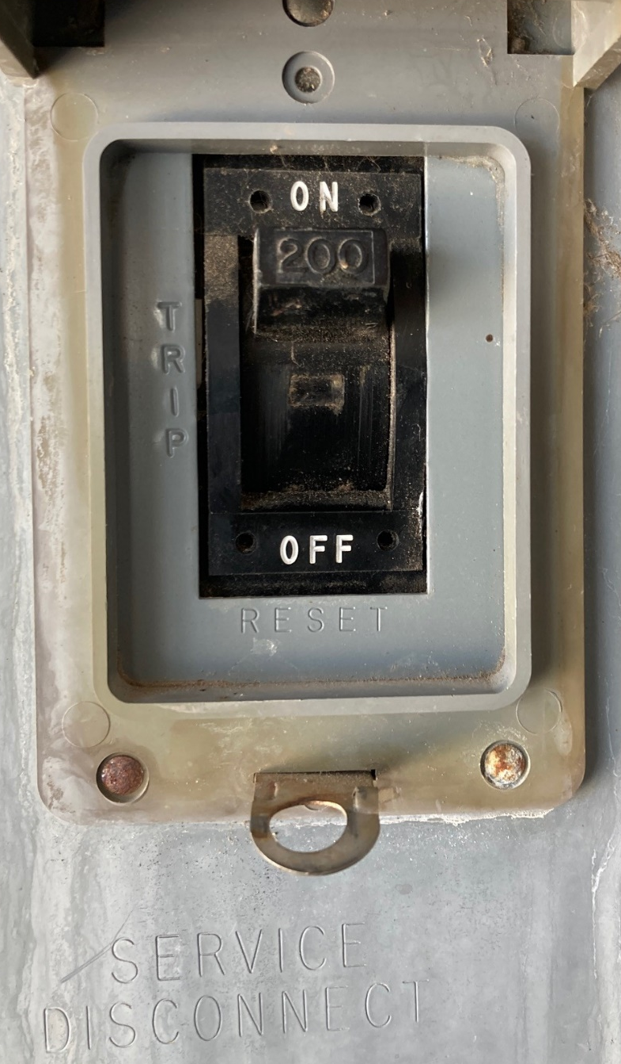
Figure 3 - The main breaker is found outside the home near the utility meter. The toggle switch shows "200" which indicates the home has 200A service.
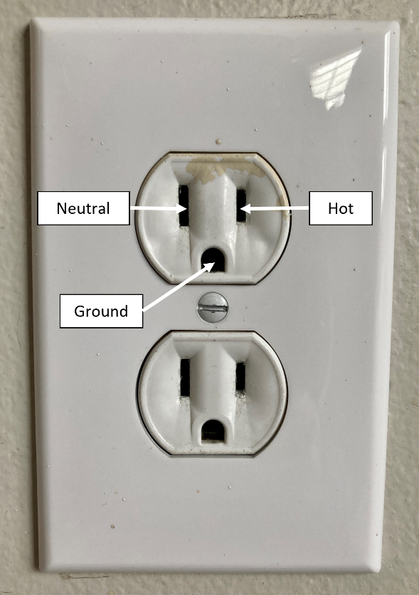
Figure 4 - A typical residential outlet (NEMA 5-15) with hot, neutral, and ground connectors
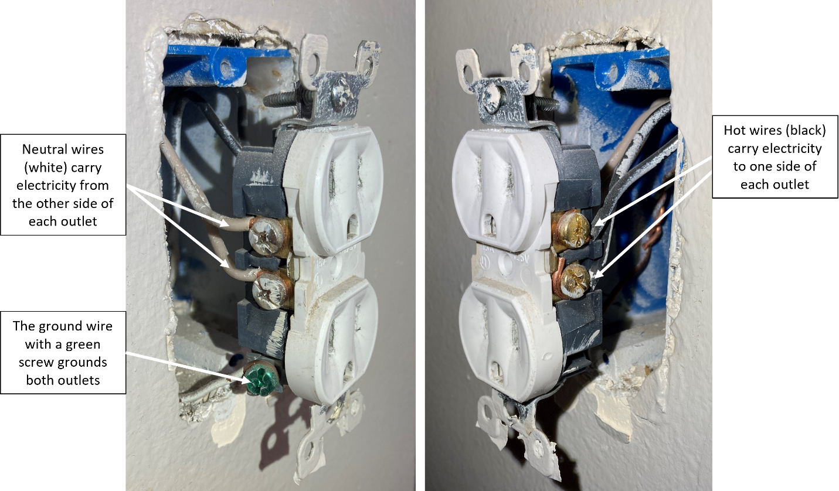
Figure 5 - Two views of a NEMA 5-15 plug with plate removed and pulled away from the wall, showing hot (black), neutral (white), and ground wire (bare, connected by a green screw).

Problem Set 2.2:
- Match the following Key Terms with the correct definition.
Definition | Key Term
- ____ is attached to ground rods that ensure the electricity always has a safe path to ground, which prevents electrocution | - Neutral bus bar
- ____ are large electrical terminals that carry electricity to the circuit breaker | - Electrical load
- ____ carries the electricity from the circuit breaker through a “hot” wire (often black or red wire) to the appliance and returns the used electricity back to the neutral bus bar through the neutral wire (often white wire) | - Ground bus bar
- The switch directly after the utility meter that can be flipped to cut power to everything downstream | - Short circuit
- An accidental circuit with no intentional load | - Circuit breakers
- Any component of a circuit that consumes energy, like an appliance plugged into an outlet or light fixture | - Service wires
- ____ is attached to the neutral service wire and used to return the electricity back to the electrical grid | - Main bus bars
- _____ carry electricity through overhead or in-ground lines from the electrical grid, through the utility meter, and into the home’s panel | - Branch wiring
- The amount of electrical current that if exceeded, the breaker will cut power to that circuit. | - Main breaker
- ____ attach to the main bus bars, controlling the flow of electricity into the branch wiring, as well as serving as a safety device designed to protect against overcurrent or short circuit. | - Amperage rating

- Imagine you have a set of three outlets on a 20A, single pole circuit breaker. You want to make tea in your 1000W electric kettle, heat up a breakfast burrito in the 1500W microwave, and make toast in the 800W toaster all at the same time. Will the circuit breaker trip? (Hint: use the equation watts = volts x amps).

Note that the panel rating may be different from the main breaker. If the values are different, it’s safest to assume to lower number.
The supplying utility may need to be contacted for determining the maximum amp service for the home without upgrading service wires.

