Building Science Education Solution Center – Duct Leakage Testing
Proficiency Level 3: Apply
Learning Objective 3.1:
- Understand how to conduct both “Total Duct Leakage” and “Duct Leakage to the Outdoors” types of duct leakage tests.
Lecture Notes 3.1:
References:
BASC Guide “Duct Leakage to Outdoors” updated 6/6/2018: https://basc.pnnl.gov/resource-guides/duct-leakage-outdoors
BASC Guide “Total Duct Leakage Tests” updated 6/6/2018: https://basc.pnnl.gov/resource-guides/total-duct-leakage-tests
2021 International Energy Conservation Code R403.3.6 “Duct Leakage” Updated September 2021: https://codes.iccsafe.org/content/IECC2021P2/chapter-4-re-residential-energy-efficiency#IECC2021P2_RE_Ch04_SecR403.3.6
How to Test Total Duct Leakage (Rough-In or Post-Construction):
- For duct testing at rough-in, perform the test before drywall and finished flooring are installed, and after the air handler, ducts, and duct boots (register boxes) are installed. For duct testing post-construction, perform the test after the air handler, ducts and duct boots, drywall or finished flooring, and registers are installed. Connect the duct blaster by attaching the duct that comes connected to the calibrated fan to a return duct grill with suitable tape (Figure 1). If conducting the test at rough-in, if there are any cabinets that connect duct boots to toe-kick registers, they do not need to be installed. If testing ducts post-construction, visually inspect the ducts prior to drywalling, to fix any obvious areas of leakage. A smoke test could also be conducted at this time to assist in making corrections before drywalling.
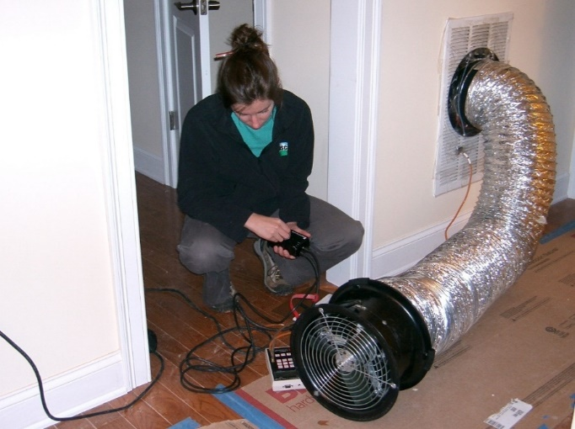
Figure 1. An energy rater uses a duct blower to test HVAC duct air leakage.
(Reference: BASC – Total Duct Leakage Tests)
- Ensure that the air handling unit is turned off. Temporarily seal shut all of the other supply and return duct registers using cardboard and tape or removable adhesive plastic (Figures 2 and 3). Make sure that the ventilation damper is closed and/or the ventilation intake is similarly sealed.
- Set up the duct blaster to either pressurize or depressurize the duct system (follow manufacturer’s instructions). Set up the manometer to measure pressure and air flow according to the manufacturer’s instructions.
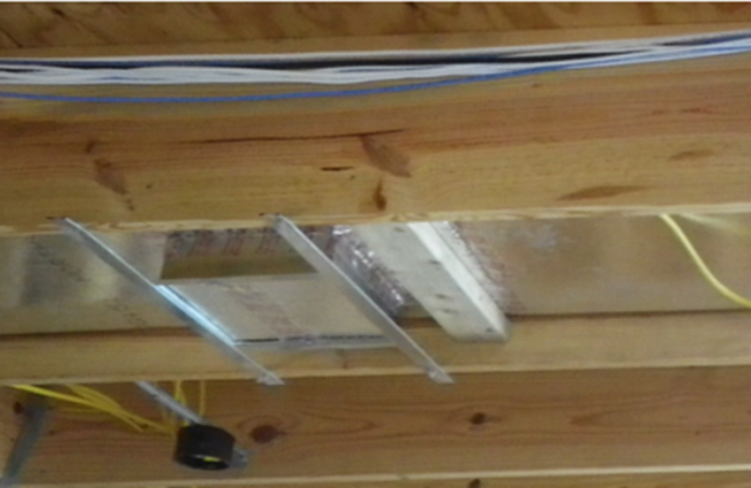
Figure 2. An example of covering the supply outlets and return inlets for a total duct leakage test at rough-in.

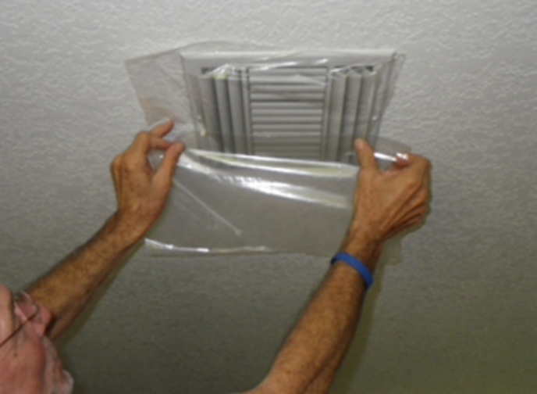
Figure 3. An example of covering the supply outlets and return inlets for a total duct leakage test at post-construction.

- Connect the "input" on the pressure side of the manometer (the black tube in Figure 4) to the return side of the air handling unit.
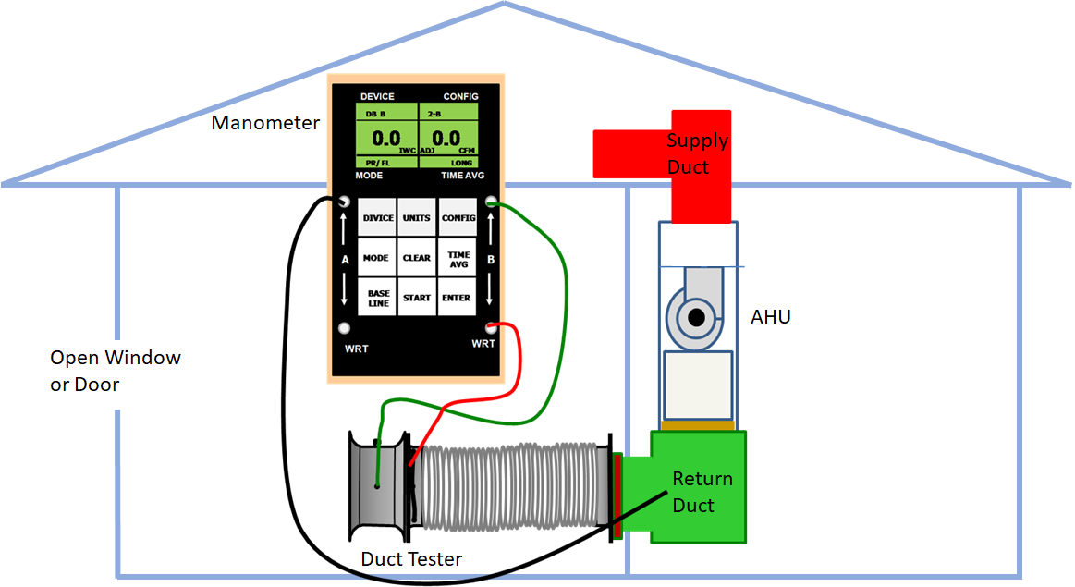
Figure 4. The duct tester is set up to test for total leakage.
- Turn on the fan to pressurize the ductwork to 25 pascals (or depressurize the ductwork to -25 pascals if depressurizing). Leave at least one door or window open between the building and outside to equalize indoor and outdoor pressures.
- Once a steady 25 pascals of pressure is reached in the duct system, note the manometer reading for CFM. This reading of the fan air flow needed to maintain 25 pascals of pressure is the amount of air escaping through the leaks in the duct system, indicated in cubic feet per minute.
- Reconnect the input (black tube in Figure 4) to a supply duct in a part of the house that is some distance from the return. Repeat steps 5 and 6. Record the duct leakage.
- Add the two duct leakage measurements together and divide by two. This will give the most accurate duct leakage measurement for total duct leakage.
- If duct leakage is too high, use a theatrical smoke machine to indicate duct leakage locations to the HVAC contractor.
- The air handling unit can be sealed with tape to reduce air leakage.
When to test for Total Duct Leakage:
After ducts are installed and before drywall is installed, the duct system should be visually inspected to ensure that all duct connections are properly fastened and sealed, preferably with mastic. At rough-in, this inspection should also ensure that all ducts are fully insulated (to R-8 for supply ducts and R-6 for returns and other ducts) along the length, including all connections, and that the insulation is not compressed by tight strapping, by framing members, or by excessive bending.
If duct leakage is tested at rough-in, for areas where the air handler is installed, the tester should confirm and document that total duct leakage is < 4 CFM25 per 100 ft² of conditioned floor area using a RESNET-approved testing protocol, such as the duct leakage test described in this document. For areas where the air handler is not installed at the time of the test, the tester should confirm and document that total duct leakage is < 3 CFM25 per 100 ft² of conditioned floor area. When testing for duct leakage post-construction, verify with a visual inspection that duct boots are sealed to finish surfaces.
If all ducts and air handlers are located entirely within the building thermal envelope, then when testing for duct leakage post-construction, the tester should confirm and document that total duct leakage is < 8 CFM25 per 100 ft² of conditioned floor area using a RESNET-approved testing protocol.
An optional, additional duct leakage test may be performed prior to drywall installation or make use of a theatrical smoke machine to look for air leaks so they can be sealed before drywalling.
According to the IRC and IECC codes, a duct air-leakage test shall not be required for ducts serving HVAC systems that are not integrated with ducts serving heating or cooling systems.
How to Test Duct Leakage to the Outdoors:
- Attach the duct that comes connected to the duct tester to the largest return duct grille using tape. Set up the duct tester per manufacturer's instructions to either pressurize or depressurize the duct system (whichever is preferred).
- Ensure the air handling unit is turned off. Temporarily seal shut all of the other supply and return duct registers using cardboard and tape or removable adhesive plastic. Make sure that the ventilation damper is closed and/or the ventilation intake is similarly sealed.
- Install a blower door in an exterior door that opens to a central location in the home. If the duct tester is set up to pressurize the duct system, then set up the blower door to pressurize the home (fan blowing in). If the duct tester is set up to depressurize the duct system, set up the blower door to depressurize the home (fan blowing out). Regarding pressurizing versus depressurizing, the test will work either way, the decision is up to the rater.
- Close all exterior doors and windows between the building and the outside during the test.
- Turn on the blower door fan and bring the building pressure to 25 pascals with reference to the outdoors (or -25 pascals if depressurizing, as shown in Figure 5 below).
- Turn on the duct tester fan and increase the air flow until the pressure inside the duct system is 0.0 (±0.1 pascal) with reference to the home. When both the house and the ducts are pressurized to 25 pascals (or depressurized to -25 pascals) with respect to outdoors, there should be no air flowing through duct leaks into the house. During this time, the blower door fan speed may have to be adjusted to make sure the home stays at 25 pascals (or -25 pascals) with reference to outdoors.
- Note on the manometer connected to the duct tester the amount of air flow needed to maintain the duct pressure at 0 pascals with reference to the home. This number, in CFM, is the amount of duct leakage to the outside of the home’s air barrier, for example into an unconditioned attic or crawlspace.
- Take two measurements: the first measurement with the duct tester pressure probe in the return duct as shown in Figure 5 and the second with the duct tester pressure probe in a supply duct as far as possible from the return that the duct tester is connected to. Add both measurements together and divide by two. This will be the average measured duct leakage to the outdoors. Testing both the supply and return ducts can also show you where dominant sources of leakage are in the duct system, on the return side or on the supply side.
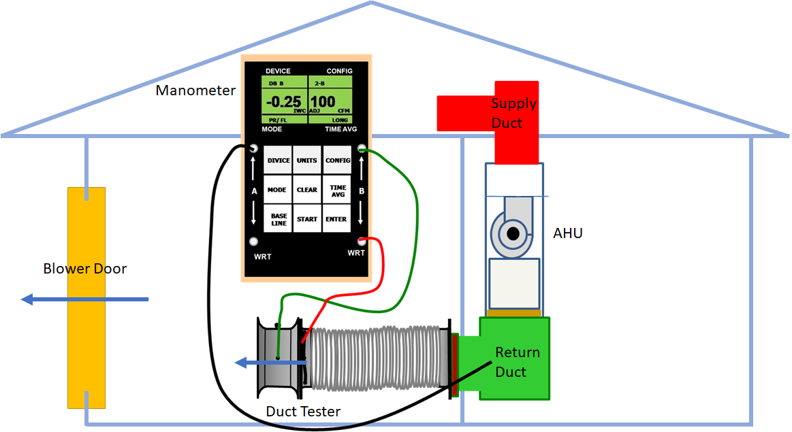
Figure 5. The duct tester and blower door are set up to measure leakage to the outdoors. The blower door is set to depressurize the house to -25 pascals with respect to the outdoors. Then the duct tester is set to depressurize the duct system to 0 pascals with reference to the house. The flow reading on the right side of the manometer indicates duct leakage to the outside in CFM. In this case, duct leakage to the outdoors is 100 CFM at 25 pascals. Some raters prefer to do this test with the fans reversed so that they pressurize the house and ducts to 25 pascals rather than depressurizing the house to -25 pascals.
When to Test for Duct Leakage to the Outdoors:
After ducts are installed and before drywall is installed, the duct system should be visually inspected by a Home Energy Rating System (HERS) rater to ensure that all duct connections are properly fastened and sealed, preferably with mastic. After all HVAC components, including registers and grilles, have been installed over finished surfaces (such as drywall or carpeting), the ducts should be tested for air leakage and proper air flow.
A HERS rater should confirm and document that duct leakage to the outdoors is ≤ 4 cubic feet of air flow per minute at 25 pascals (CFM25) per 100 ft² of conditioned floor area using a Residential Energy Services Network (RESNET)-approved testing protocol, such as the duct leakage test described in this document. An optional, additional duct leakage test can be conducted prior to drywall installation. If the leakage level is above 4 CFM25 per 100 ft² of conditioned floor area, the builder, rater, or HVAC contractor may use a smoke machine to determine exact locations of leakage so they can be sealed before drywalling. If the Prescriptive Path has been chosen the ducts should also be visually inspected to confirm that they are fully insulated (to R-8 for supply ducts and R-6 for returns and other ducts) along the length, including all connections, and that the insulation is not compressed by tight strapping, by framing members, or by excessive bending.
Photo Examples:
Images Links: https://basc.pnnl.gov/resource-guides/total-duct-leakage-tests#edit-group-training
Incorrect Installation Examples:
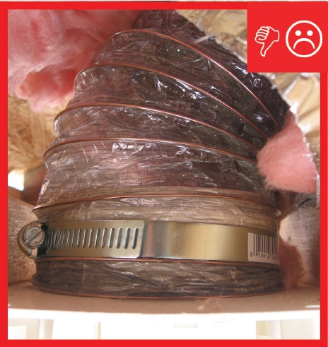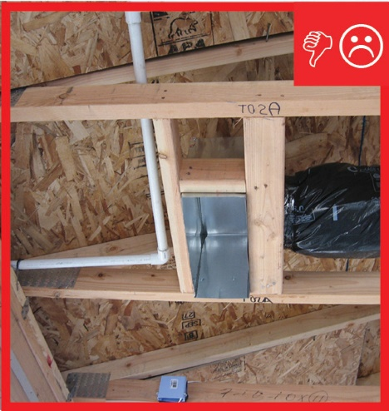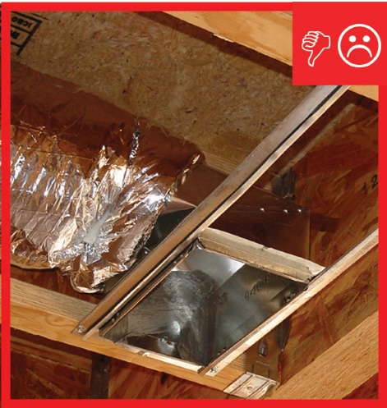
Left: Connection in place but not sealed. Center & Right: Insulation does not cover boot and is not sealed.
Correct Installation Examples:
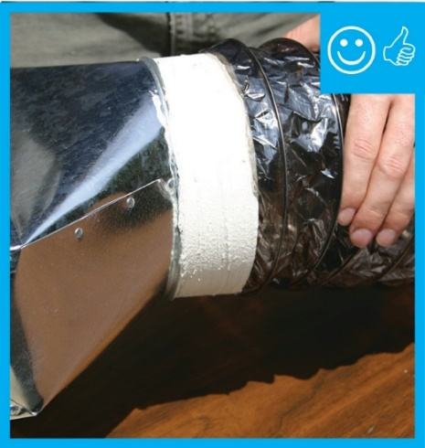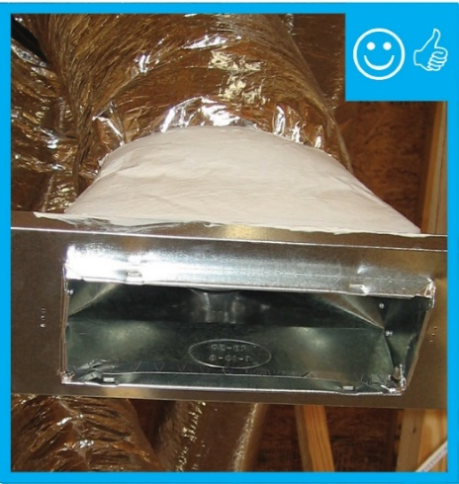
Left: Duct connection is Mechanically fastened and sealed. Right: Duct boot has been covered with insulation and sealed with mastic.
Video Examples:
Duct Leakage to Outdoors (BMI, February 2015):
- Part 1: https://www.youtube.com/watch?v=dpaM7K1TOlM
- Part 2: https://www.youtube.com/watch?v=E7rEhqsgbjY
Total Duct Leakage Tests: https://www.youtube.com/watch?v=jhrTsq-jEzo
Additional Reference:
RESNET Standard 803 “On-site Inspection Procedures for Duct Leakage Testing”: https://www.resnet.us/wp-content/uploads/Chapter-Eight-22RESNET-Standard-for-Performance-Testing-and-Work-Scope-Enclosure-and-Air-Distribution-Leakage-Testing22.pdf
Problem Set 3.1:
- What is the approval leakage limit according to RESNET-approved testing protocol for total duct leakage testing for a home at rough-in?
  - < 2 CFM25 per 100 ft² of conditioned floor area
  - < 4 CFM25 per 100 ft² of conditioned floor area
  - < 2 CFM25 per 50 ft² of conditioned floor area
  - < 4 CFM25 per 50 ft² of conditioned floor area
- How should a blower door and duct tester be installed for conducting a duct leakage to the outdoors test?
  - The blower door should be set up to pressurize the home and the duct tester should be set up to pressurize the duct system.
  - The blower door should be set up to depressurize the home and the duct tester should be set up to depressurize the duct system.
  - Either a. or b.
- During a test for duct leakage to the outdoors, the first measurement with the duct tester pressure probe in the return duct read a leakage of 40 CFM, and the second measurement with the duct tester pressure probe in a supply duct as far as possible from the return the duct tester is connected to read a leakage of 120 CFM. What is the average measured duct leakage to the outdoors, and where is the greater source of leakage?
- What steps are done differently in a duct leakage to the outdoors test compared to a total duct leakage test?
Learning Objective 3.2
- Understand what suitable materials and sealants are used in duct sealing and where they should be applied.
Lecture Notes 3.2:
Some examples of materials suitable for ductwork and duct sealing can be found in the following reference:
“Measure Guideline: Combustion Safety for Natural Draft Appliances Through Appliance Zone Isolation”, Section 5.3 “Materials for Ductwork and Duct Sealing:
https://www1.eere.energy.gov/buildings/publications/pdfs/building_america/measure_guide_combustion_safety_appliancezone.pdf

Acceptable materials for ductwork and duct sealing include:
- Tapes for metal ductwork marked Underwriters Laboratories (UL) 181A-P
- Mastic that meets UL 181 A-M
- Fiberglass duct board that meets UL 181A
- For Non-metallic flexible ducts (do not use cloth backed tapes):
  - Tape labeled UL 181B FX
  - Mastic that meets UL 181B-M
  - Mechanical fasteners labeled UL 181B-C.
- Aerosol sealant with a flame index smoke index ration of 25/50 with a class 1 flame spread is approved for all joint seals when applied by manufacturer certified installers to manufacturer’s standards.
- Duct coverings, linings and adhesives that have a flame index/smoke index ratio of 25/50 according to either the ASTM International (ASTM) E 84 or UL 723 Standards.
- Two-part spray foam meeting the International Code Council’s (ICC) International Residence Code (IRC) 2012 M1601.4.1, and IRC R316.6 tested for its intended uses to: National Fire Protection Association (NFPA) 286 within acceptance criteria of IRC R 302.9.4, FM Global (FM) 4880, UL 1040, or UL 1715 and reported in an International Code Council – Evaluation Service (ICC ES) report as meeting requirements of code, requires no additional sealants.
- Single component sealant foam: use material accepted as fire stop in wood frame construction and approved for limited exposed use in ICC-ES reports see ESR 1961-12, ESR 1862-11, ESR 1926-12.
- Standards References:
  - ASTM: https://www.astm.org/
  - UL: https://standardscatalog.ul.com/Default.aspx
  - FM 4880: https://standards.globalspec.com/std/1273435/4880
  - NFPA: https://www.nfpa.org/
  - IRC: https://codes.iccsafe.org/content/IRC2018
  - ICC-ES https://icc-es.org/

