Building Science Education Solution Center – Duct Leakage Testing
Proficiency Level 2: Understand
Learning Objective 2.1:
- What are the components of a duct blaster used to test for duct leakage?
Lecture Notes 2.1:
Reference Link: BASC Guide “Duct Leakage to Outdoors” updated 6/6/2018: https://basc.pnnl.gov/resource-guides/duct-leakage-outdoors
Testing heating and cooling duct distribution systems for air leakage is done following compliance to building codes such as the International Residential Code (IRC) and the International Energy Conservation Code (IECC). Organizations such as the Residential Energy Services Network (RESNET) have developed testing protocols that adhere to these standards, for example, ANSI/RESNET/ICC 380-2019: Standard for Testing Airtightness of Building, Dwelling Unit, and Sleeping Unit Enclosures; Airtightness of Heating and Cooling Air Distribution Systems; and Airflow of Mechanical Ventilation Systems (link: https://www.resnet.us/wp-content/uploads/ANSIRESNETICC_380-2019_vf1.24.19_cover%5E0TOC-2.pdf) and ASTM E1554: Standard Testing Methods for Determining Air Leakage of Air Distribution Systems by Fan Pressurization (link: https://www.astm.org/e1554_e1554m-13r18.html). Duct leakage testing is performed using a duct tester, such as the Minneapolis Duct Blaster or the Retrotec Duct Tester. A duct tester consists of a calibrated fan that is used to either pressurize or depressurize the duct, and a device such as a manometer that is used to measure fan air flow and building pressure. Supplies such as cardboard and tape or adhesive plastic sheeting are also used to seal off the building’s supply and return registers during the test (See Figure 1). The fan is used to pressurize or depressurize the duct system to 25 pascals (a measure equivalent to 0.10 inch water column). Once the pressure differential is at 25 pascals, the air flow through the duct tester is read in cubic feet of air flow per minute; this measurement is abbreviated as CFM25.
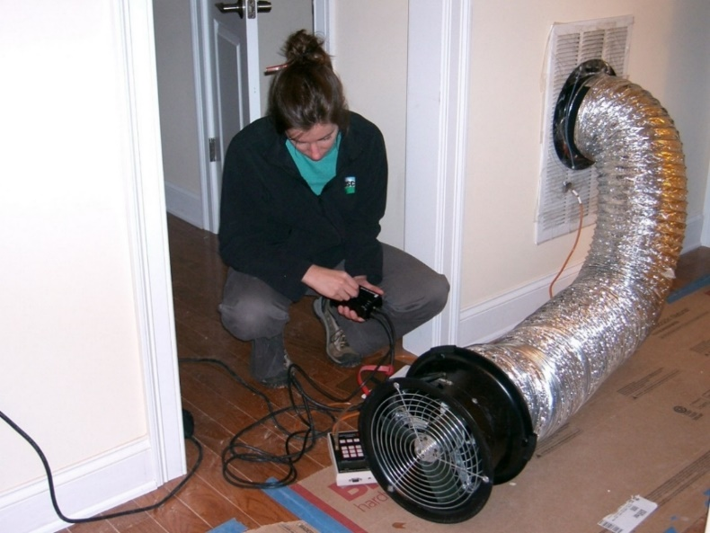
Figure 1. An energy rater uses a duct blower to test HVAC duct air leakage. (Image Source: BASC – Duct Leakage to Outdoors)
Problem Set 2.1:
- What are the components of a duct tester?
Learning Objective 2.2:
- Understand what the two different types of duct leakage testing are, the acceptable leakage limits for each test, and when they are used.
Lecture Notes 2.2:
References:
BASC Guide “Duct Leakage to Outdoors” updated 6/6/2018: https://basc.pnnl.gov/resource-guides/duct-leakage-outdoors
BASC Guide “Total Duct Leakage Tests” updated 6/6/2018: https://basc.pnnl.gov/resource-guides/total-duct-leakage-tests
2021 International Energy Conservation Code R403.3.6 “Duct Leakage” Updated September 2021: https://codes.iccsafe.org/content/IECC2021P2/chapter-4-re-residential-energy-efficiency#IECC2021P2_RE_Ch04_SecR403.3.6
ANSI/RESNET/ACCA 310-2010 “Standard for Grading the Installation of HVAC Systems” updated 6/23/2020: https://www.resnet.us/wp-content/uploads/ANSIRESNETACCA_310-2020_v7.1.pdf
ENERGY STAR Single-Family New Homes Quality Assurance & Certification Review Checklists, Version 3 / 3.1 (Rev. 11), updated 12/11/2020: https://www.energystar.gov/sites/default/files/ES%20Certified%20Homes%20QA%20Checklist_Rev%2011_2020-12-17.pdf
ENERGY STAR Single-Family New Homes and Multifamily New Construction Duct Leakage to Outdoors Test Exemptions, updated 4/27/2021: https://www.energystar.gov/sites/default/files/asset/document/Duct%20Leakage%20Exemptions%20Guide%20-%20ENERGY%20STAR%20SFNH%20Rev11_MFNC%20Rev02.pdf
Two types of duct leakage tests are performed: the “total duct leakage” test and the “duct leakage to the outdoors” test. Duct leakage testing should be performed after all components of the system have been installed, including the air handler, the ductwork, and the register boxes or duct boots.
Total Duct Leakage:
The “total” duct leakage test measures how much leakage there is for all the ductwork connected to the HVAC system, including ducts located both inside and outside the building envelope. Tests for total duct leakage can be done at either rough-in or post-construction. “Rough-in” is when the air handler and ducts have been installed and sealed but before drywall or flooring and registers are installed (this includes cabinets (e.g., kitchen, bath, multimedia) or ductwork that connect duct boots to toe-kick registers). “Post-construction” is after the air handler and ducts, drywall and flooring, and registers have been installed.
According to IECC requirements when testing for duct leakage at rough-in, the total leakage must be < 4.0 CFM per 100 ft² of conditioned floor area where the air handler is installed at the time of the test. Where the air handler is not installed, the total leakage at rough-in must be < 3.0 CFM per 100 ft² of conditioned floor area. When testing post-construction, the total duct leakage must be < 4.0 CFM per 100 ft² of conditioned floor area. However, if all ducts and air handlers are located entirely within the building’s thermal envelope, then the total duct leakage must be < 8.0 CFM per 100 ft² of conditioned floor area. Additionally, there is an exemption in the IRC and IECC requirements where a duct air-leakage test shall not be required for ducts serving HVAC systems that are not integrated with ducts serving heating or cooling systems.
Organizations can have their own criteria to evaluate the duct leakage of buildings while adhering to building codes. For example, RESNET uses a graded criteria to determine the quality of a duct system’s installation. Duct systems are given a Grade I, II, or III, from most desirable to least desirable, based on the amount of total duct leakage of the system. According to ANSI/RESNET/ACCA 310-2010, “Task 2: Evaluation of the Total Duct Leakage” (pp. 19-21 of the linked document), the Grading criteria are as follows:
For Grade I: When testing at rough-in: the duct Leakage must be < 4 CFM25 per 100 ft² of conditioned floor area if there are less than 3 returns in the system, or < 6 CFM25 per 100 ft² of conditioned floor area if there are 3 or more returns in the system. When testing at final: the duct Leakage must be < 8 CFM25 per 100 ft² of conditioned floor area if there are less than 3 returns in the system, or < 12 CFM25 per 100 ft² of conditioned floor area if there are 3 or more returns in the system.
For Grade II: When testing at rough-in: the duct Leakage must be < 6 CFM25 per 100 ft² of conditioned floor area if there are less than 3 returns in the system, or < 8 CFM25 per 100 ft² of conditioned floor area if there are 3 or more returns in the system. When testing at final: the duct Leakage must be < 10 CFM25 per 100 ft² of conditioned floor area if there are less than 3 returns in the system, or < 14 CFM25 per 100 ft² of conditioned floor area if there are 3 or more returns in the system.
If the duct leakage limits for Grade II are exceeded, the duct system is designated as Grade III.
ENERGY STAR uses duct leakage test results to determine if a residence qualifies for their Certified New Homes program requirements across the U.S. The criteria for ENERGY STAR’s Certified Homes program (Version 3.1 Rev 11) specifies that the measured air leakage criteria for total duct leakage tests must be the greater of either ≤ 8 CFM25 per 100 ft² of conditioned floor area or ≤ 80 CFM, or if the duct system has three or more returns, the total measured air leakage must be the greater of either < 12 CFM25 per 100 ft² of conditioned floor area, or < 120 CFM.
In any case, if duct leakage testing is done during rough-in, the tester must return after the drywall has been installed to visually confirm that the duct boot is sealed to the drywall. Even if the duct leakage testing is done post-construction instead, ducts should still be visually inspected at rough-in to look for any obvious gaps or misses in duct mastic so those can be corrected before drywalling. Some home energy raters will also recommend that the ducts be tested at rough-in with a low-CFM smoke machine. The machine is connected to one of the ducts while all the other registers are closed off so that the HVAC contractor can clearly see and fix any leaks in the ducts revealed by the smoke.
If testing is conducted post-construction, registers installed over carpets are permitted to be removed and the face of the duct boot temporarily sealed during testing. The tester should also visually verify that the duct boots have been durably sealed to the subfloor (using duct mastic or caulk) to prevent leakage during normal operation.
There are pros and cons to testing at either rough-in or post-construction. Some builders prefer to test for duct leakage at rough-in when the ducts are easier to access in case additional air sealing needs to be done. However, some builders, especially those who install ducts in the attic, prefer to wait until post-construction to test the ducts because the ducts are likely to get moved about by other trades during construction and ducts will still be accessible for the final evaluation.
Duct Leakage to the Outdoors:
The "duct leakage to the outdoors" test measures only duct leakage outside of the home’s air barrier. This could include leakage into an unconditioned attic, crawlspace, or an attached garage. This test must be performed post-construction, once the building envelope is complete.
The 2021 versions of the IRC and IECC codes do not distinguish between total duct leakage and leakage to outdoors specifically, but according to ENERGY STAR Certified Homes (Version 3/3.1, Rev 11), the duct leakage to the outdoors test can sometimes be waived. According to ENERGY STAR’s Duct Leakage to Outdoors Test Exemptions document, in compliance with standards ANSI/RESNET/ICC 301 and 380, testing of duct leakage to the outdoors is not required if all ducts and air handling equipment are located within the home’s pressure and thermal boundaries and as long as the ductwork is 100 percent fully ducted with no building cavities being used as supply or return ducts.
In cases where the above conditions do not apply, testing of duct leakage to the outside can still be waived if the leakage results from the total duct leakage test is ≤ 4 CFM25 per 100 ft² of conditioned floor area, (or < 40 CFM, whichever is larger).
Leakage limits are assessed on a per-system, rather than per-home, basis. For example, if a home has two furnaces, duct leakage must be measured in each system and compared to the square footage that the system conditions. Each system must meet the “total” and “outdoors” leakage requirements to qualify for the ENERGY STAR program.
Problem Set 2.2:
- Under what conditions do the two duct leakage tests need to be conducted?
- What is the difference between duct leakage testing at “Rough-In” and testing done “post-construction”?
- For a home with a single duct system and more than 1,200 square feet of conditioned floor area, what must the total duct leakage be to not have to conduct a duct leakage to the outdoors test?
  - < 2 CFM25 per 100 ft² of conditioned floor area.
  - < 3 CFM25 per 100 ft² of conditioned floor area.
  - < 4 CFM25 per 100 ft² of conditioned floor area.
  - < 5 CFM25 per 100 ft² of conditioned floor area.

Learning Objective 2.3:
- Understand the impact duct leakage can have on energy losses in high-performance homes.
Lecture Notes 2.3:
Energy Loss from Duct Leakage:
High-performance homes are homes built using materials that greatly reduce heat transfer through conduction, convection, and radiation. As a result, the high-performance homes of today have much smaller HVAC systems and lower rates of duct airflow than older houses of the same volume, providing energy and cost savings. At these low airflows, relatively small amounts of duct leakage can disrupt the proper distribution of air and starve some rooms of the air they need to maintain comfort conditions. Therefore, it becomes even more important that the conditioned air does not get lost in duct leakage.
The measured duct leakage can be compared to rated air handler flow to get a sense of the energy penalty that duct leaks are contributing in Btu/h (this is not an ENERGY STAR requirement). Cooling systems move 400-450 cubic feet of air per minute over the evaporator coil per ton of cooling, and each cubic foot of air moved will carry with it 30 Btu/h. A 2.5-ton cooling system moves 1,000 CFM of air and puts out 30,000 Btu/h. If that system has a measured duct leakage of 10% (100 CFM25), it is losing 3,000 Btu/h (1/4 ton) of cooling to the outdoors.

