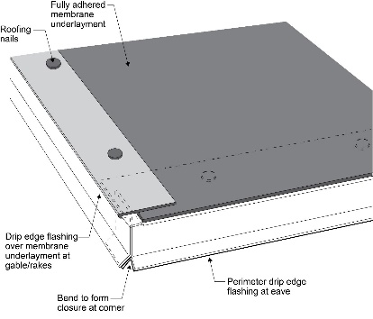 | WHAT?  When roofing a new home, you should take the opportunity to improve its resistance to high winds, hurricanes, tornadoes, and earthquakes. In high-wind zones, it is recommended that drip edges be installed at roof eaves and roof rakes. Drip edge is installed after a fully adhered membrane or sheathing tape has been installed.
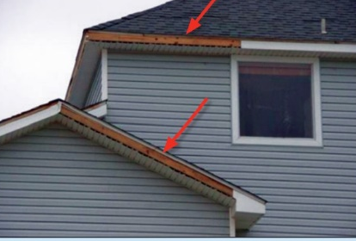 | WHY?  Even small breaches in the roof can lead to extensive destruction of the home and its contents during a storm. Strengthening the roof is one of the best ways that builders can increase the disaster resistance of a home. Installing drip edge over the underlayment at all eaves and rakes can help lock the roof in and protect it from moisture intrusion.
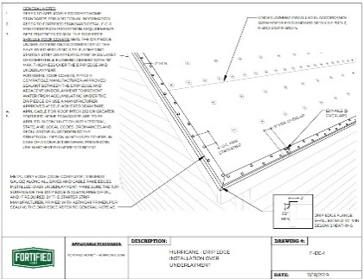 | HOW?  Code-compliant metal drip edges should be installed at all eaves and gable rake edges over the fully adhered membrane underlayment. They should extend a minimum of ½ inch below sheathing and overlap the top of the roof sheathing edge a minimum of 2 inches; they should overlap a minimum of 3 inches at joints. The drip edge should be mechanically fastened to the roof deck at a maximum spacing of 4 inches. At eaves, flashing cement should be used to seal the edges.
ROOFING: DRIP EDGE AT ROOF EAVES AND RAKES

