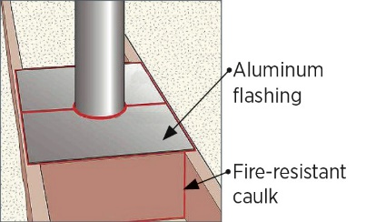 | WHAT?  Air barriers installed around flue shafts in the attic floor prevent air leakage between the living space and the attic. They also allow full insulation levels to be installed around the flue. These air barriers are made from noncombustible materials and help maintain and adequate distance between the flue and combustible materials.
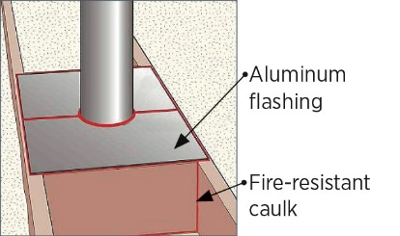 | WHY?  Air barriers should be installed around duct and flue shafts in the attic floor to prevent air leakage between the living space and the attic and to allow full insulation levels to be installed around the duct or flue. Air barriers around flue shafts should be made of a heat-resistant material such as sheet metal to protect against the fire hazard.
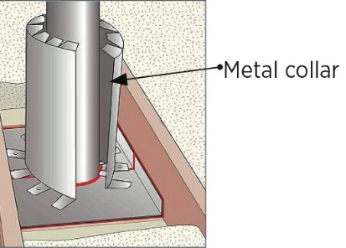 | HOW?  Flue pipe openings may be air sealed at the top or bottom of the attic framing. If at the top, full-height blocking must first be installed perpendicular to the ceiling joists. In both cases, two pieces of sheet metal or aluminum flashing should be installed to fit around the chimney pipe, leaving 1 inch of overlap. The sheet metal should be fastened to the framing and edges and seams sealed with fire-rated caulk. Finally, install a metal shield around the pipe, leaving a 3-inch clearance. The shield should be 4 inches taller than finished insulation level, and the edges should be sealed together with fire-rated caulk.
FRAMING: DRAFTSTOPPING & FIREBLOCKING: AIR SEALING FLUE PIPES

