BSESC—Disaster Resistance and Resiliency

Proficiency Level 4: Analyze

Learning Objective 4.1
- Analyze and then provide specific examples in writing to demonstrate how applied building science has been used to make buildings more disaster resistant and resilient than traditional building practices.

Lecture Notes 4.1
The Building America Solution Center (available at www.basc.pnnl.gov) provides access to expert information on hundreds of high-performance construction topics, including air sealing and insulation, HVAC components, windows, indoor air quality, and much more.

Within the Building Components section of the Building America Solution Center (e.g., wall structure) are detailed best practice guides based on the latest building science that can be used as lecture notes. Summary notes are provided here from one of these guides that address objective 4.1 above.

Insulated concrete forms can be used in both residential and commercial construction. They have proven to be disaster resistant to tornadoes, hurricanes and other natural disasters. (An example is described in the FEMA news release of July 7, 2008, #R8-08-011, entitled “Insulated Concrete Forms, Other Measures, Make Home Disaster Resistant.”)

As described in more detail at https://basc.pnnl.gov/resource-guides/insulated-concrete-forms-icfs#quicktabs-guides=1, insulated concrete form (ICF) construction combines concrete and rigid foam for walls that are thick, sturdy, and continuously insulated. Studies comparing ICFs with stick-frame construction have shown that in otherwise identical homes, the ICF houses had a 9% better whole-wall R-value and were 10% more airtight (Christian 1996). ICF walls have almost no thermal bridging in the wall itself and, with proper design details, thermal bridging can be almost eliminated at the rim joist as well (Petrie et al. 2003; Desjarlais et al. 2002).
ICFs are typically made of pre-molded blocks or panels of rigid foam, which are assembled on site to create wall forms into which concrete is poured (Figure 1). The foam forms stay in place, providing permanent insulating foam layers on the interior and exterior of the wall. Foam blocks are typically comprised of two 2-inch-thick, 16 by 48-inch rectangles of foam that are connected by plastic, metal, or foam ties. The ties hold the foam panels 6 or 8 inches apart during the pour and remain in place afterward. The blocks are stacked like bricks to create the wall forms for the concrete. Steel rebar is added to the cavities for additional strength (Figure 2). Some ICFs come with plastic nailing strips embedded in their exterior surfaces. The foam is typically expanded polystyrene (EPS). Some ICF products use extruded polystyrene (XPS) foam, which is stronger but more costly. A few products are made with recycled foam or wood. Some ICF walls consist of two layers of concrete sandwiching a central layer of foam.
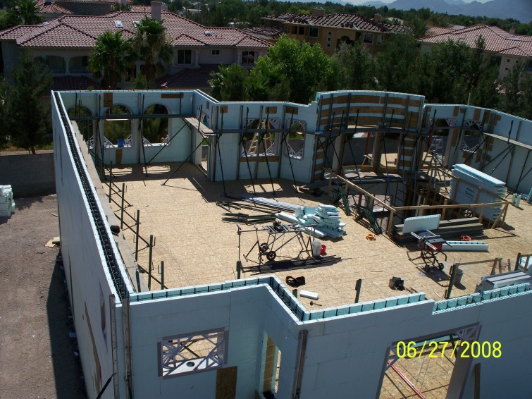
Figure 1 - ICFs provide continuous wall insulation from the roof to footing with very little thermal bridging; the ICFs in this home in Las Vegas provide R-40 wall insulation.

Common types of ICF walls are shown in Figures 3 and 4. A flat ICF wall system is a solid concrete wall of uniform thickness with sheets of insulation forming the interior and exterior surfaces of the system. The waffle-grid ICF wall system is a concrete wall composed of closely spaced vertical (maximum 12 inches on center) and horizontal (maximum 16 inches on center) concrete members with concrete webs between the members. The screen-grid ICF wall system is similar to a waffle-grid ICF wall system without concrete webs in between the vertical and horizontal members. The post-and-beam ICF wall system has vertical and/or horizontal concrete members spaced farther than 12 inches on center.

ICF systems are installed in a manner similar to masonry, starting at the corners and placing a layer at a time to build up the wall. Most manufacturers make specifically molded corner blocks that provide a continuous layer of foam around the corner to reduce thermal bridging there (Figure 5). Window and door openings must be framed with lumber (Figure 6). Lumber blocking is also needed where bearing pockets are required for floor or roof supports. Ledgers can be mounted to the blocks for attaching floor framing.

Once the forms are in place and braced, and required reinforcement is installed, concrete is pumped into the forms (Figure 7). Even with the bracing, the forms need to be filled at an appropriate rate based on the ICF manufacturer’s recommendations to prevent misalignment and blowouts. Form failures are rare when the manufacturer’s recommendations are followed. Reinforcement in both directions maintains the wall strength. A good item to have on hand when the concrete arrives is a blowout repair kit. Unless a self-consolidating concrete mix is used, concrete should be vibrated after pouring to remove trapped air as air pockets can lead to thermal bridging and weaken the cement (ICF Builder 2012).
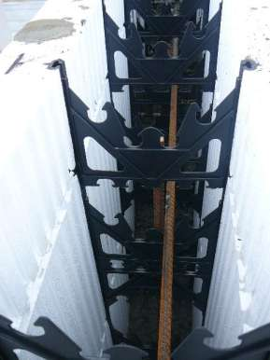
Figure 2 - The ICF consists of wall forms made of rigid foam blocks or panels that are held in place with plastic or metal spacers and reinforced with metal rebar.
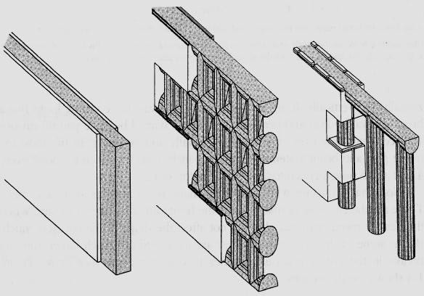
Figure 3 - Three common ICF wall systems: the flat wall, the waffle wall, and the post-and-beam wall.
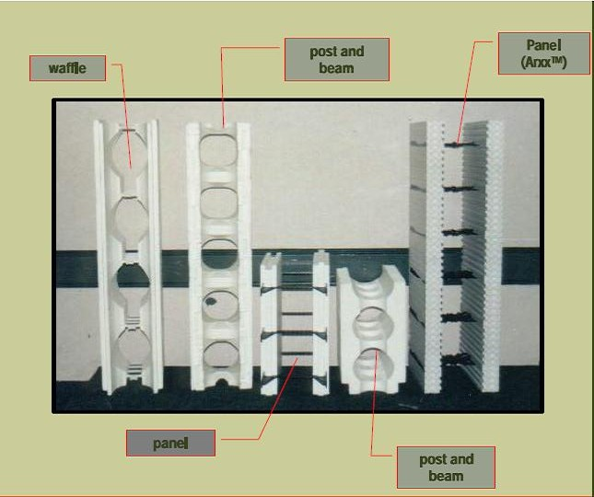

Figure 4 - Different types of ICF blocks.
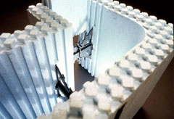
Figure 5 - The blocks stack to form walls. Special molded corners provide continuous insulation layer at the corners to improve structural strength and minimize thermal bridging.
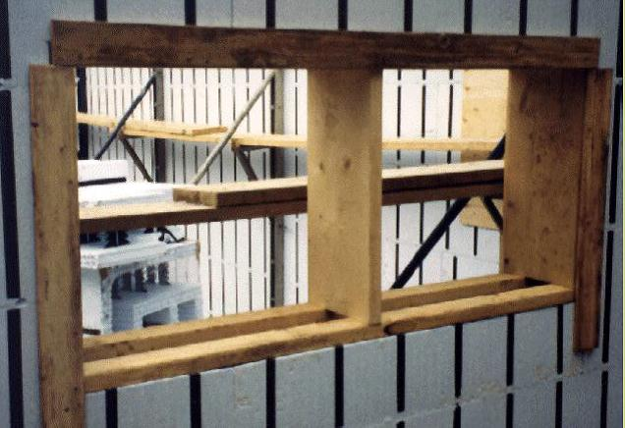
Figure 6 - Window and door rough openings in the ICF wall are surrounded with pressure-treated wood.

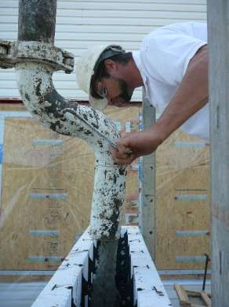
Figure 7 - A pumper is used to place the concrete into the foam form walls.

More detail is provided at https://basc.pnnl.gov/resource-guides/insulated-concrete-forms-icfs#quicktabs-guides=1, including how to install ICFs, how to brace ICFs, notes about installing utilities, and code and ENERGY STAR compliance details.

Learning Objective 4.2
- Analyze and summarize in writing with one specific example how disaster resistant and resilient design can also be energy-efficient design, and as a result, cost efficient over time.

Lecture Notes 4.2
There are many examples of disaster resistant and resilient design also being energy-efficient design. Since objective 4.1 focuses on insulated concrete form (ICF) construction, this objective continues with this example, although many examples are available and relevant. See the internet links in the references below for more details.

Insulated concrete forms have proven to be disaster resistant to tornadoes, hurricanes and other natural disasters. (An example is described in the FEMA news release of July 7, 2008, #R8-08-011, entitled “Insulated Concrete Forms, Other Measures, Make Home Disaster Resistant.”)

Insulated concrete form (ICF) construction, as a result of the use of insulating form materials (i.e., polystyrene foam), provides an inherently high level of thermal resistance. In field comparisons of similar ICF and wood-frame house constructions, it has been found that ICF wall construction can provide a 20 to 25 percent savings in annual heating and cooling costs (HUD 1999). In 2001 costs, to achieve a similar level of energy performance, a typical wood-frame home would require an “energy upgrade” that adds about $2,640 to an average home cost of $200,000 (or about $1.32 per square foot of living area). This amount is equivalent to about one-third of the cost difference between ICF and typical wood-frame house construction.

Building science research published in 2014 (Mallay and Wiehagen 2014) simulated hourly energy use of an ICF wall compared with a light-frame wall system of the same R-value during a very cold (in climate zones 4 and 5) period in the heating season shows an average of 9% less annual energy use and as much as a 30% energy use reduction for a given hour period.

References

Mallay, D. and J. Wiehagen. September 2014. Insulated Concrete Form Walls Integrated with Mechanical Systems in a Cold Climate Test House. Prepared by Home Innovation Research Labs Partnership for Home Innovation (PHI) for the National Renewable Energy Laboratory On behalf of the U.S. Department of Energy’s Building America Program. http://www.nrel.gov/docs/fy14osti/62539.pdf

NAHB Research Center, Inc. 2001. Costs and Benefits of Insulating Concrete Forms for Residential Construction. Prepared for The U.S. Department of Housing and Urban Development Office of Policy Development and Research Washington, D.C. https://www.huduser.gov/portal/Publications/PDF/icfbenefit.pdf

U.S. Department of Housing and Urban Development (HUD). December 1999. Insulating Concrete Forms: Comparative Thermal Performance. HUD, Washington, D.C.

