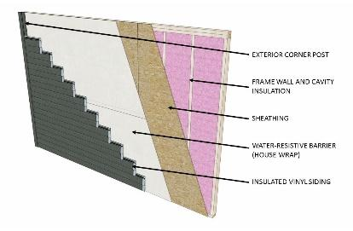 | WHAT?  Housewrap is the most common air barrier material. This material, which usually consists of spun polyolefin plastic, is used to wrap around the exterior of a house during construction. To serve as an air barrier, the housewrap must be sealed at the joints using special tape. This tape improves the wrap's performance by about 20%.  Sealing housewrap joints with tape improves the wrap's performance by about 20%.
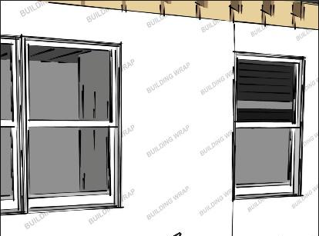 | WHY?  Housewrap is commonly used as a weather-resistive barrier, or WRB; it functions as a drainage plane to prevent moisture that gets behind cladding from reaching other building materials. Housewrap may serve as a continuous air barrier, but only if all conditions are met. It must be integrated with flashing materials in order to perform.
HOW?

Housewrap must be fully sealed at all seams and edges and supported using approved fasteners. Special attention must be paid to windows and other openings. The housewrap should be cut in a modified “I” pattern and the flaps folded over and fastened to the inside of the framing.

After the head and jamb flashing is installed, unfold the housewrap and lay over the head flashing. Tape bottom edge of housewrap across the top window flange and tape down corner seams of housewrap.
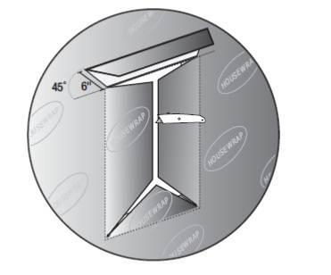
CONTINUOUS AIR BARRIER ON EXTERIOR WALLS: HOUSEWRAP

