CAPILLARY BREAK BENEATH SLAB
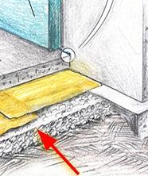 | WHAT?  To prevent moisture from wicking up into the concrete slab and foundation walls, a waterproof layer should be put in under the concrete. Under this plastic sheeting barrier, there should be a 4-inch gravel layer to help moisture drain away. With crawlspaces, plastic sheeting should also be installed over the dirt floor.
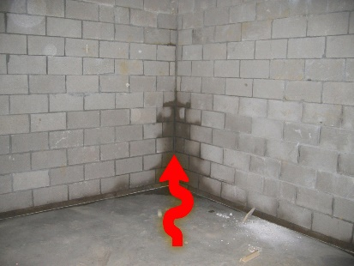 | WHY?  Without an effective moisture barrier, water can penetrate the pores of a concrete foundation slab, which can lead to moisture problems. These layers are part of complete foundation floor water barriers, which help drain water away from under the slab and minimize the risk of water damage in the basement.
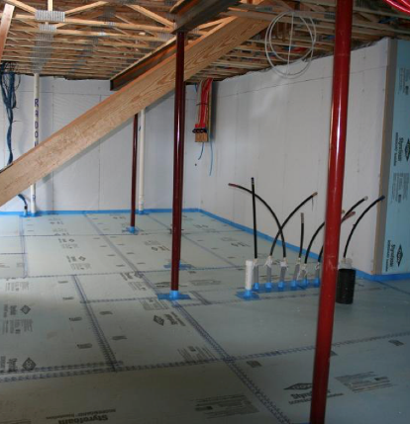 | HOW?  - Put in a capillary break beneath slab foundations consisting of 4 inches of aggregate stone or 4 inches of sand covered by geotextile matting.  - Place a vapor barrier over this consisting of:  - ≥ 6-mil polyethylene sheeting with 6-12 inches lapped and seams sealed, or  - ≥ 1-inch extruded polystyrene rigid foam insulation and taped joints  - Seal the sheeting or foam at the joints with foundation walls and around posts or pipes coming up from the ground to maintain the continuous vapor barrier.

