CARPET INSTALLATION: LOW-VOC CARPET AND PADS

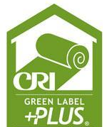 | WHAT?  Certified low-VOC and no-VOC carpets and carpet pads are the best choice for a new home’s indoor environment.
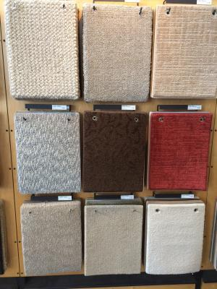 | WHY?  Traditional carpet, carpet pads, and carpet adhesives may contain volatile organic compounds (VOCs) and other chemicals that have short- and long-term adverse health effects. These can include varying degrees of eye, nose, and throat irritation; headaches; loss of coordination and nausea; allergic skin reactions; and even damage to the liver, kidneys, and central nervous system.  Installing Carpet and Rug Institute (CRI)-certified products lowers risk of inhabitant exposure to high levels of VOCs from construction materials.
HOW?
For living spaces, select third-party-certified, low-emission carpet products aimed at reducing human exposure to individual VOCs. Indoor airPLUS guidance offers compliant products, including industry databases and examples of product labeling.
Indoor airPLUS requires for a new home’s surface area covered by carpet and carpet adhesives to use products labeled with the CRI Green Label Plus testing program criteria; the carpet cushion, or padding must also be CRI Green Label Plus-certified.

