BUILDING ENCLOSURE: BUILDING SCIENCE INTRO—DRAINAGE PLANE BEHIND EXTERIOR WALL CLADDING

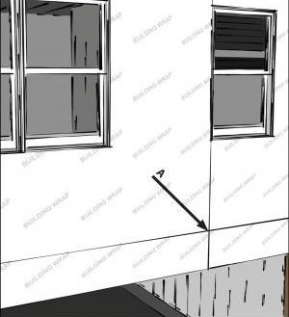 | WHAT?  A water-resistant barrier should cover the entire house and the seams should be taped as part of a comprehensive home drainage system. This continuous drainage plane should go behind the exterior cladding on the walls to keep water out of the wall cavities.  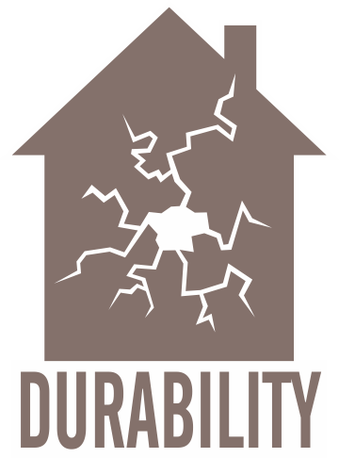
WHY?
Controlling moisture flow in a home is imperative for occupant health and safety, comfort, building durability and energy efficiency. The drainage plane, when some moisture gets past the siding, provides a path for it to safely drain down and away from the wall.
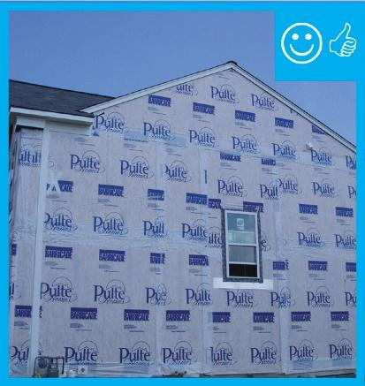 | HOW?  Install a fully sealed continuous drainage plane behind the exterior cladding on the home’s walls to protect wall cavities from moisture.  Ensure that this layer laps over flashing installed around doors, windows, and wall penetrations and any flashing installed at the top or base of walls.  Place an additional bond-break drainage plane layer behind stucco and non-structural masonry wall cladding assemblies.  Potential monolithic weather-resistant barrier (WRB) materials include housewrap that is sealed or taped at all joints; rigid foam insulation or other sheathing materials with a weather-resistant coating (if all joints are fully taped); building paper or building felt installed with shingle-style laps; liquid-applied coatings; or other WRB materials approved by the ICC-ES or another accredited agency.

