BUILDING ENCLOSURE: AIR BARRIERS VS. VAPOR BARRIERS—CONTINUOUS SEALED WRB ON WALLS

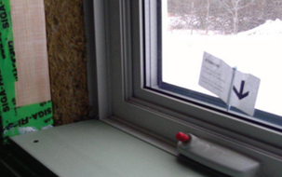 | WHAT?  In buildings, a vapor barrier or vapor retarder reduces the rate at which water vapor can move through a material. Controlling air-transported moisture requires an air barrier system or air pressure control measure that should be combined with a vapor barrier—where the air barrier may not be able to stop vapor from diffusing.  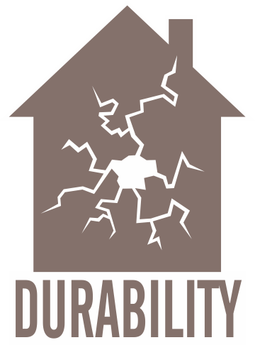
WHY?
Controlling moisture flow in a home is essential for occupant comfort, health, and safety; it’s also essential to building durability and energy efficiency. In most U.S. climates, vapor retarders should be part of a complete moisture control strategy for a home.
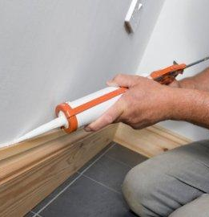 | HOW?  While air barriers should be applied everywhere in the home, vapor barriers should be applied in addition to the air barrier where vapor diffusion can be a concern. How, where, and whether a vapor retarder is needed depends on the climate and the construction of the home.  In mild climates, materials like painted gypsum wallboard and plaster wall coatings may suffice in impeding moisture diffusion. In more extreme climates, higher-perm vapor diffusion retarders are recommended.  - Install vapor retarders closest to the warm side of a structural assembly, which is toward the interior of the building in cold climates and toward the exterior in hot/wet climates.  - Make sure that the vapor retarder installation is continuous and as close to perfect as possible. Be sure to completely seal any tears, openings, or punctures and cover all appropriate surfaces to minimize moist air condensing within the cavity, which could lead to dampened insulation.

