BUILD SILL PAN: FULLY FLASHED WINDOW AND DOOR OPENINGS

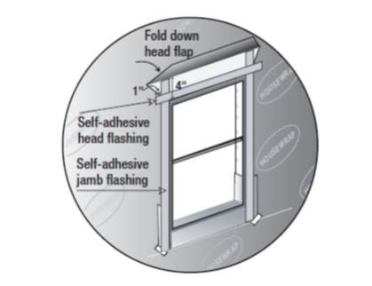 | WHAT?  To direct water out—not into—the wall cavity, put in correctly lapped flashing around window and door openings.
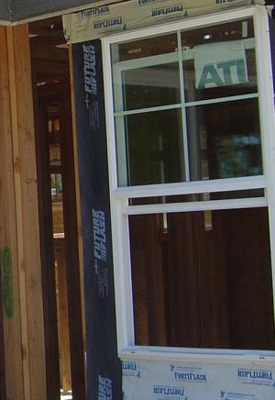 | WHY?  Windows and doors interrupt the wall’s housewrap or insulated sheathing drainage plane, so they are a vulnerable spot for water leakage. The wall framing around windows and doors must be protected from any water that finds its way behind the siding at these locations and must be directed back out and away to prevent damage to the rest of the wall. Properly installed flashing, integrated with the other elements of the wall, can help prevent water damage to the home.
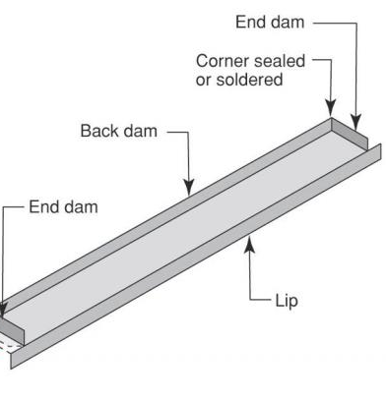 | HOW?  - Put in rigid, flexible, or fluid-applied pan flashing at sills.  - Put in window or door.  - Place side flashing that extends over the pan flashing.  - Place top flashing that extends over the side flashing.  - Correctly integrate all flashing with the housewrap.

