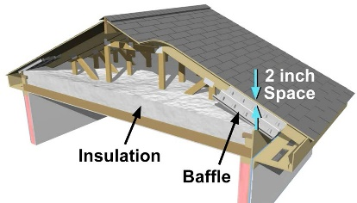 | WHAT?  In vented attics, insulation is installed over taped and mudded drywall, which serves as the continuous air barrier. To help maintain consistent insulation over this ceiling air barrier, wind dams and baffles should be installed in the attic in every rafter bay that has a soffit vent. Baffles are rigid chutes that are installed in each rafter bay.
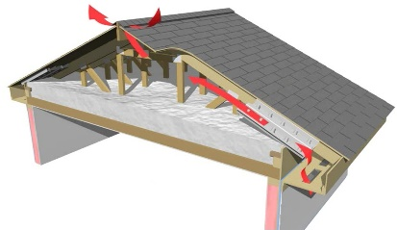 | WHY?  In ventilated attics, air movement helps cool attics and removes excess moisture, but it can interfere with insulation. For insulation to perform, it must be installed at the correct depth throughout the attic, including the eaves. Baffles help maintain an air gap between the insulation and the roof deck; they also help direct air movement and prevent wind from blowing the insulation out of place.
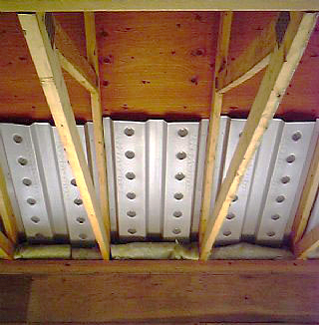 | HOW?  Baffles are 2-inch-deep chutes made of plastic, cardboard, or metal. They are usually 2 to 4 feet in length and come in widths to fit standard rafter bays. They can be connected to the wind dam; some are tabbed so that the end can be bent down to serve as the wind dam. The baffle maintains a 2-inch air gap between the underside of the roof deck and the insulation and guides air from the soffit vents toward the ridge vent.
INSULATION PROCESS/REQUIREMENTS: CEILINGS: BAFFLES

