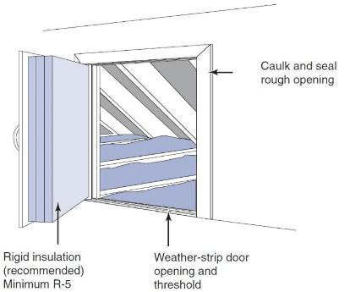 | WHAT?  Often, attics include openings that are used for access. These include access panels, doors into kneewalls, and dropdown stairs. To reduce heat loss, these openings should be air sealed and insulated.
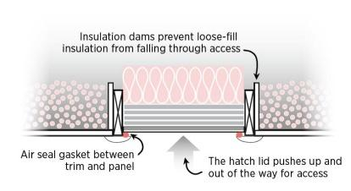 | WHY?  Good air sealing and a continuous air barrier between the attic and the home’s living space are important, not only to save energy and reduce fuel bills, but also to prevent moisture problems in the attic. Sealing holes in the attic ceiling reduces the house’s “suction” (or stack effect) so fewer contaminants such as radon and other soil gases are drawn up into the house from the ground.
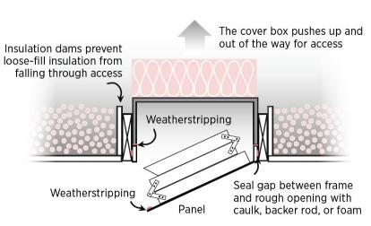 | HOW?  To air seal, a gasket made from weather stripping should be added to either the frame or panel of the attic access panel or door. Latch bolts or mechanical fastener should be installed that will pull the access door tight to the weatherstripping for an airtight seal. Panels and doors can be insulated by gluing rigid foam to the panel or attaching batt insulation with bolts and wiring or metal strapping.  Pulldown stair kits can be purchased that have rigid insulation already attached to the panel. Alternatively, a rigid foam box-shaped cover can be constructed or purchased that fits over the stairs and is lifted and placed out of the way when accessing the attic. Blocking should also be installed around the staircase or panel to keep insulation from falling into the opening.

